School Name
Mathematics 2017
Year 8 |  | Transformations and Congruence | Non Calculator  Test
Skills and Knowledge Assessed:  - Describe translations, reflections in an axis, and rotations of multiples of 90° on the Cartesian plane using coordinates. Identify line and rotational symmetries (ACMMG181)  - Define congruence of plane shapes using transformations (ACMMG200)  - Develop the conditions for congruence of triangles (ACMMG201)  - Establish properties of quadrilaterals using congruent triangles and angle properties, and solve related numerical problems using reasoning (ACMMG202) |  |  | Name_________________
Section 1 Short Answer Section
Write all working and answers in the spaces provided on this test paper.
Geometric Instruments will be needed for this test.

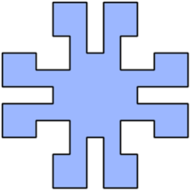
Questions 1 and 2 refer to the diagram below.

 | Draw all the axes of line symmetry on the shape.
What order of rotational symmetry does the shape have?

Order 2 Order 4 Order 8 It has none
A triangle ABC is rotated through 180º about the point B.
Which point does not change position?

Every point changes position.
Point A does not change position.
Point B does not change position.
Point C does not change position.
Use geometric instruments to draw the image after ABCDEF is reflected in the line XY.
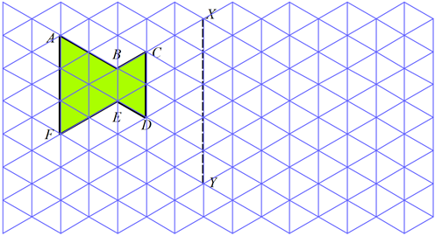

Use geometric instruments to draw the image after NOPQ has been rotated through 270º in a clockwise direction.
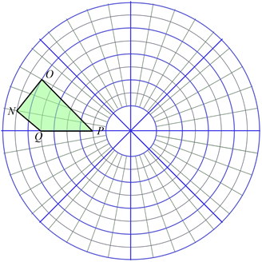

What order of rotational symmetry does the shape below have?


None 2 3 6
Use geometric instruments to draw the image after EFGH is translated in the distance and direction indicated by the arrow.
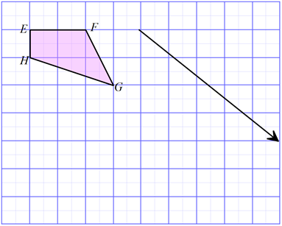

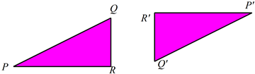
The triangle OPQ is reflected in the line OQ.
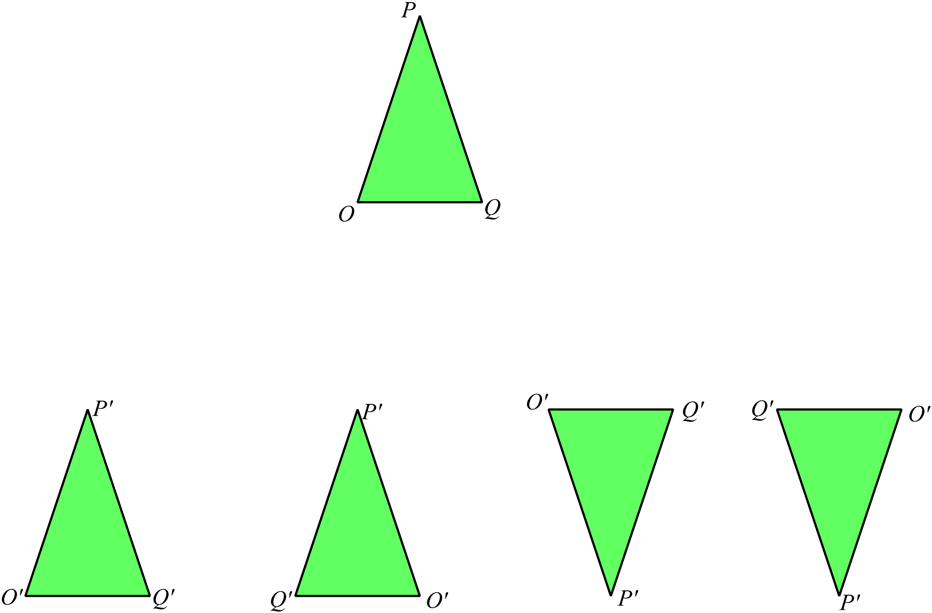

Which triangle could be the image?

The figure PQR could be transformed to the figure 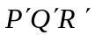 by:

Rotation through 180º.
Reflection.
Translation.
Rotation through 90º.
Which polygon has exactly 2 axes of symmetry?
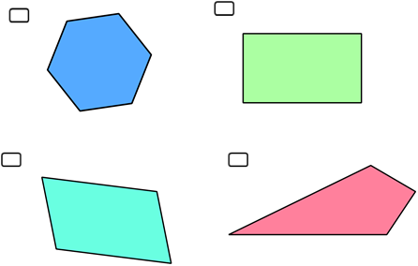

Complete the figure given that LM is an axis of line symmetry.
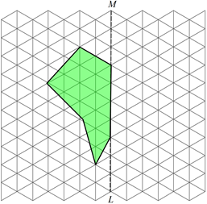

A polygon ABCDE which has its vertices labelled in a clockwise direction, is transformed to a congruent image which is also labelled in a clockwise direction.
Which of these transformations could have been used?

A reflection, a rotation or a translation. Only a reflection and a rotation.
Only a reflection and a translation Only a rotation and a translation.

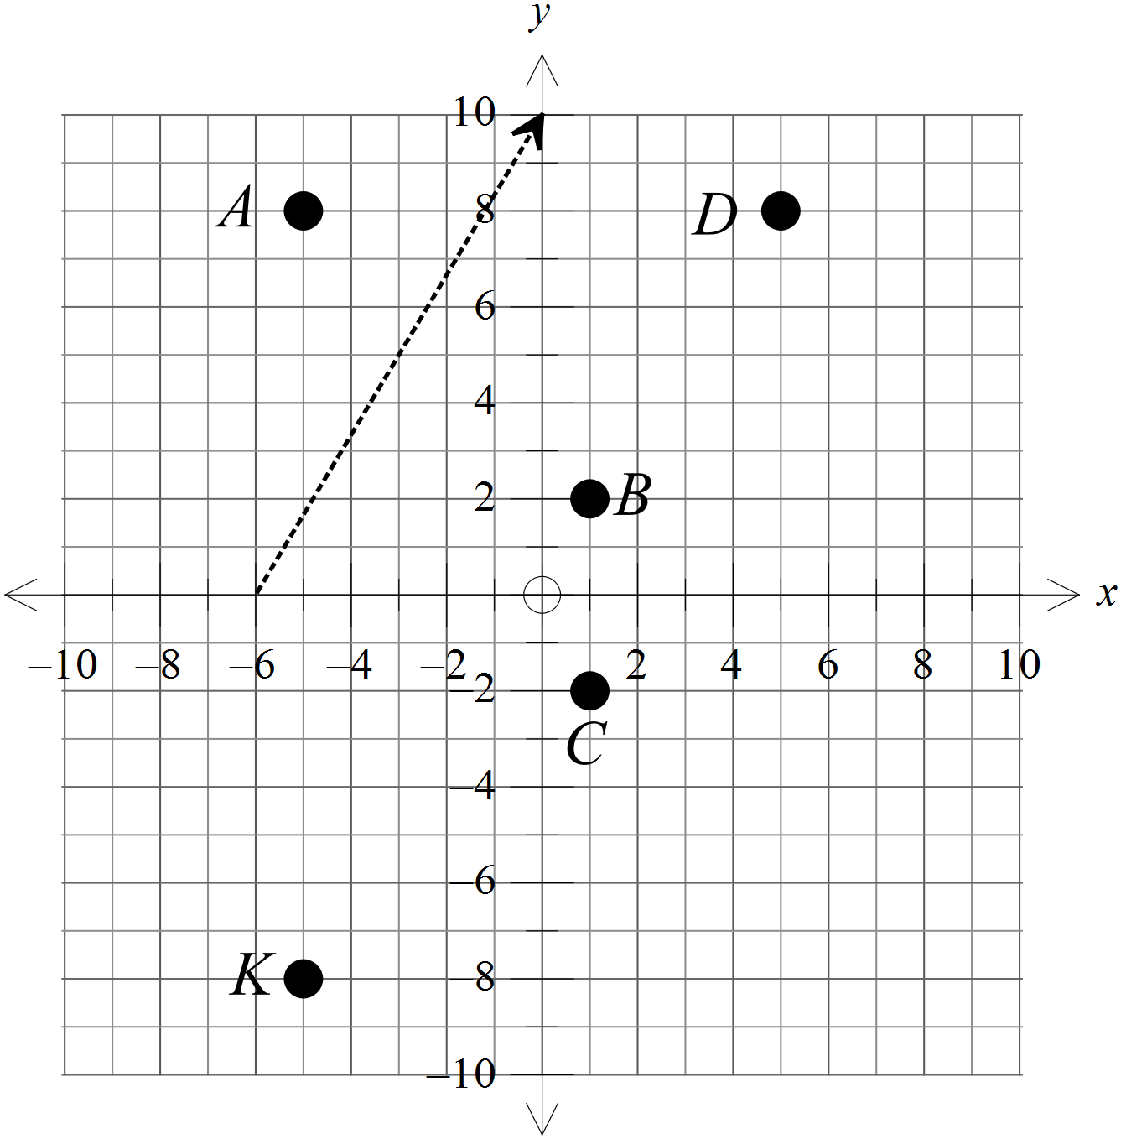The point K (–5, –8) is translated through the distance and direction indicated by the arrow.
Which point is the image after the transformation?

A (–5, 8)
B (1, 2)
C (1, –2)
D (5, 8)

 | 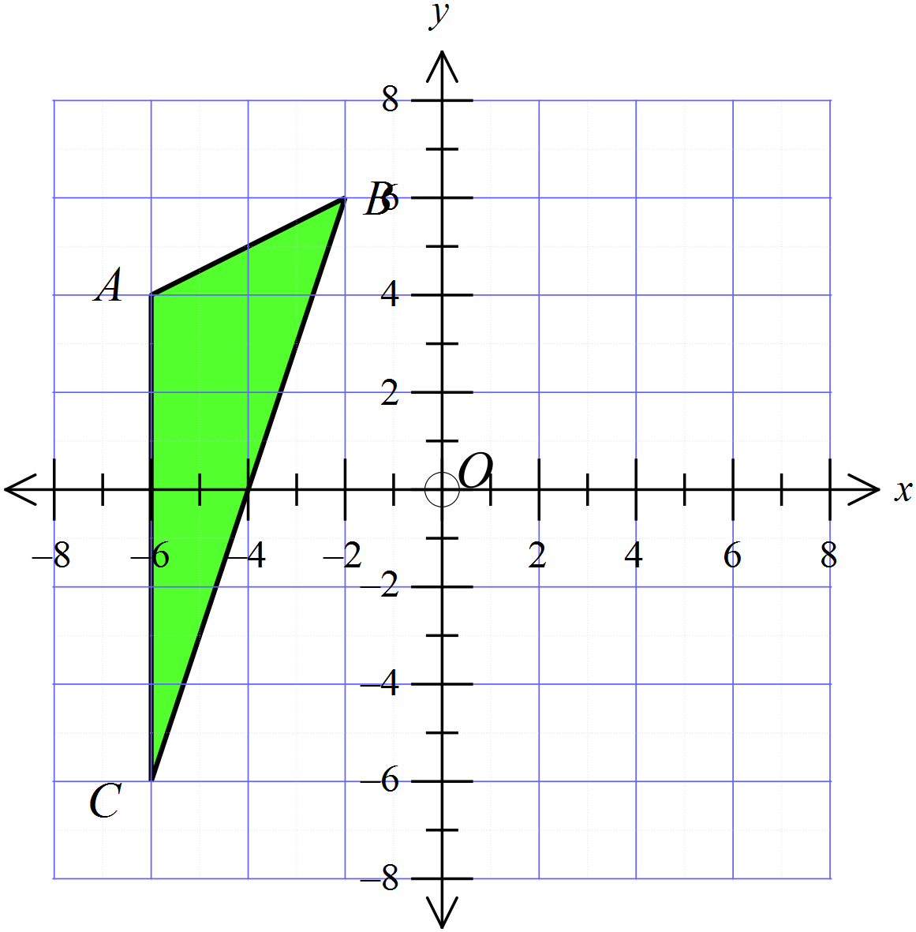Draw the image of triangle ABC after a rotation through 180º about the origin O.
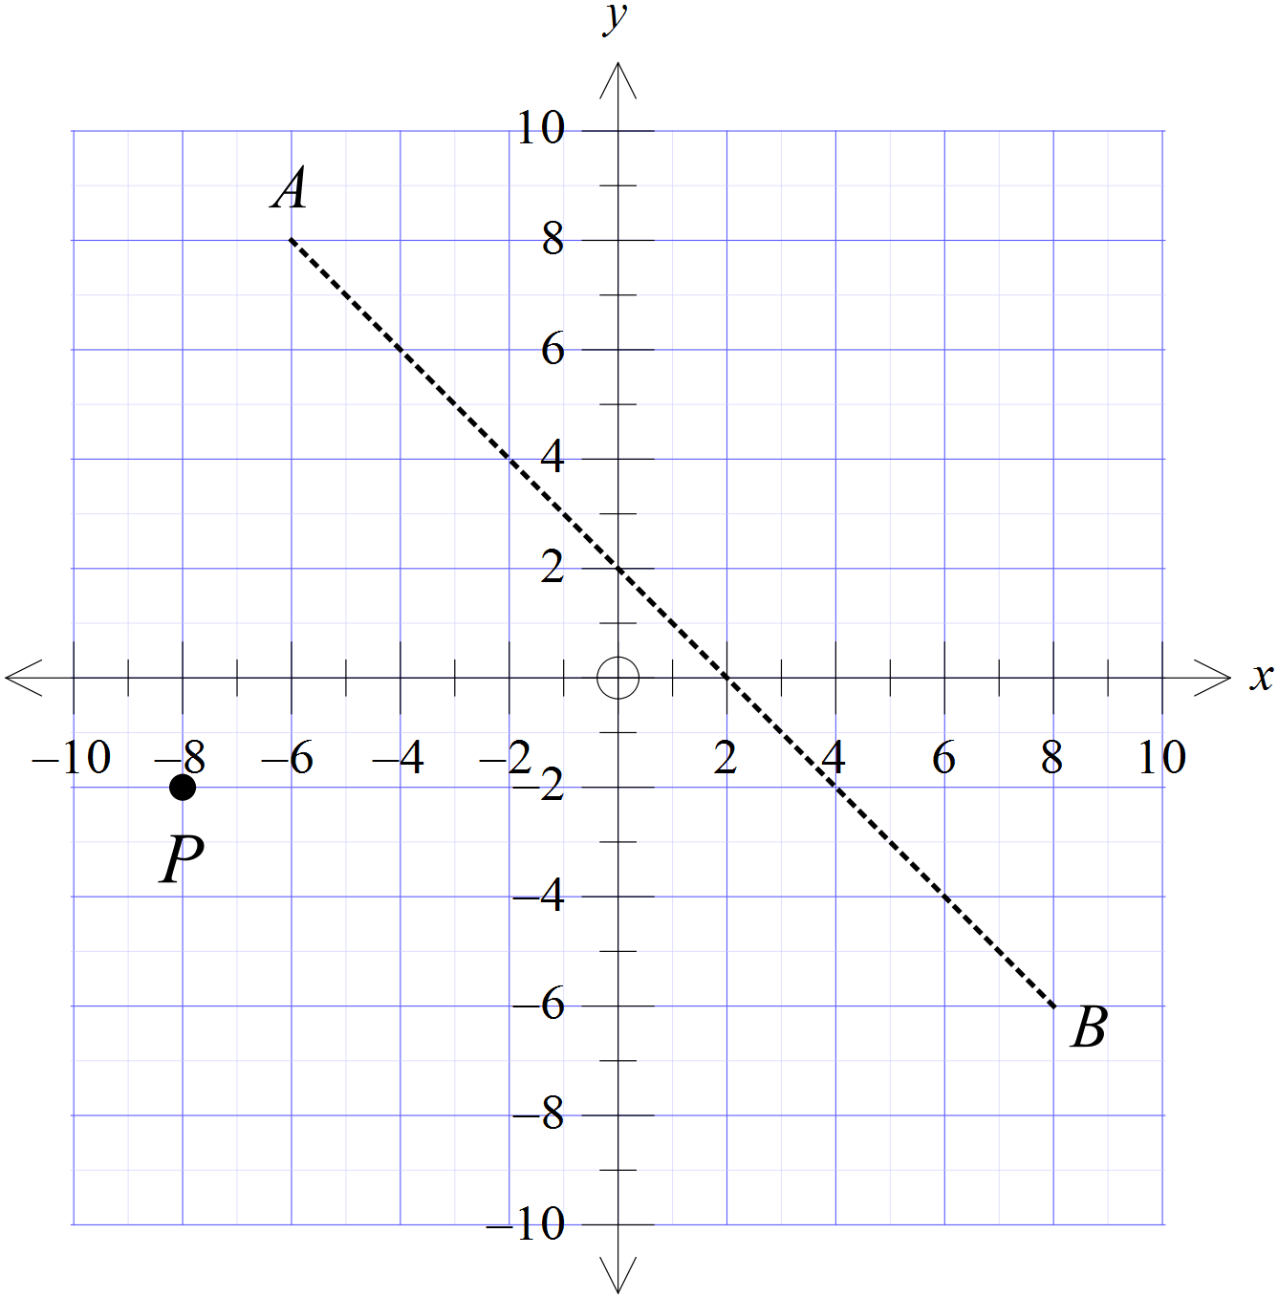The point P (–8, –2) is reflected in the line AB.
Which are the coordinates of the image after the transformation?

HHlll

Draw the position of the figure PQRS after a reflection in the line y = 2.
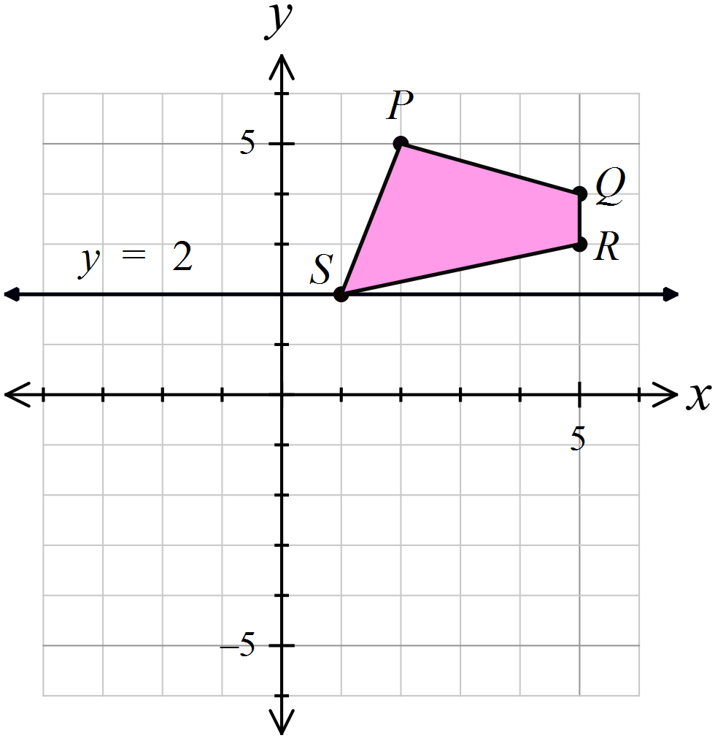

The point K (– 5, 3) is rotated through 90º in a clockwise direction about the origin O.
Which point is its image?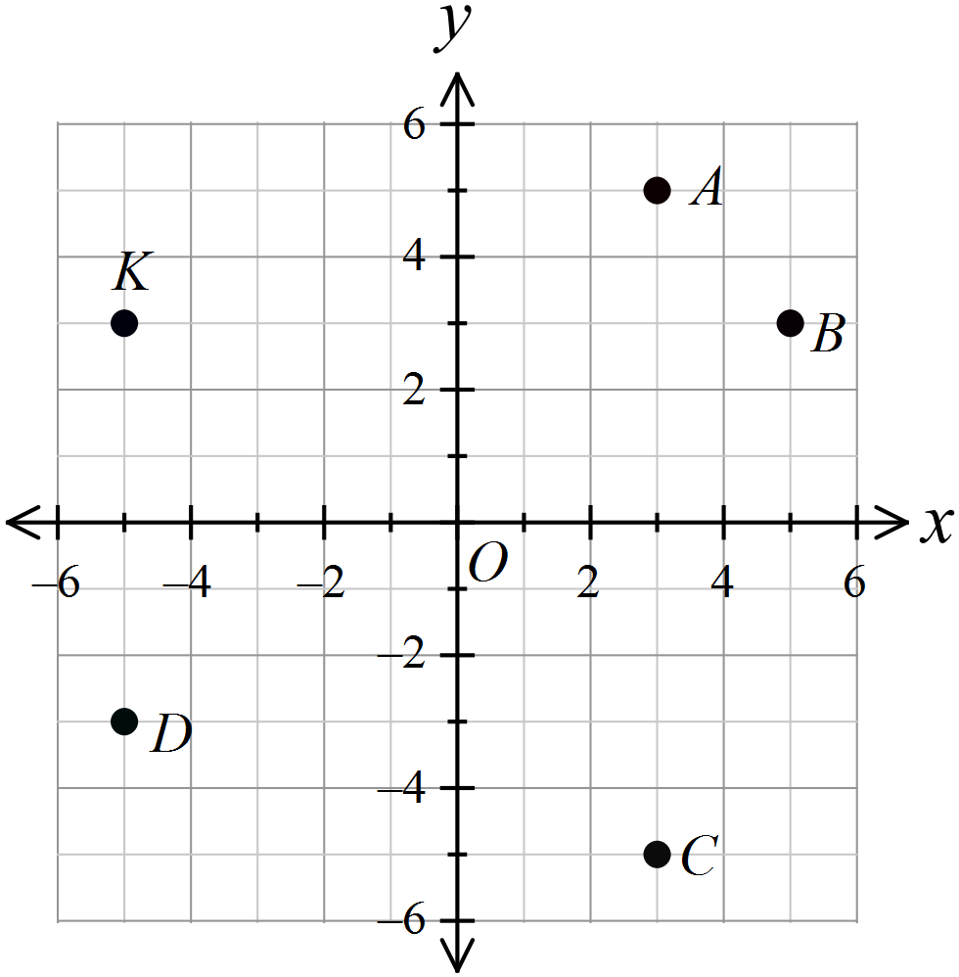

A (3, 5)
B (5, 3)
C (3, –5)
D (–5, –3)

Figure ABCD is moved to an image A’B’C’D’ by a single transformation.
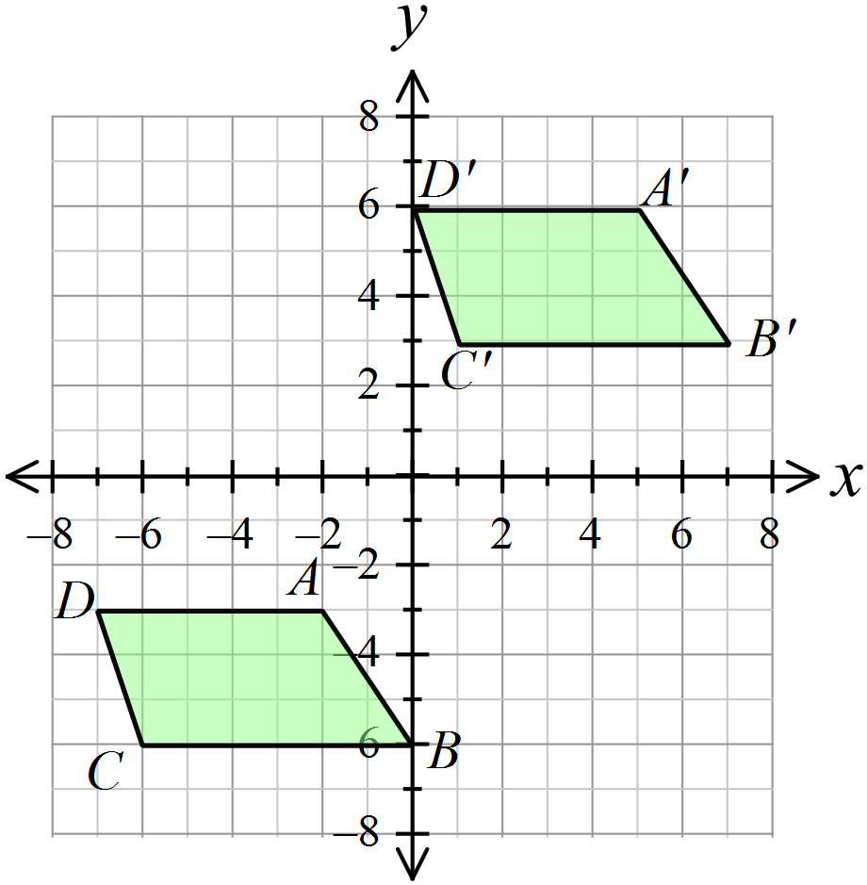What was the transformation?

A reflection in the line y = x.
A reflection in the line y = -x
A rotation of 180º.
A translation.

Quadrilateral STUV is a parallelogram.
What transformation could move
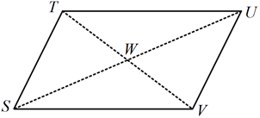
A reflection.
A rotation of 90º.
A rotation of 180º.
A translation.

A rhombus DEFG has its diagonals drawn, intersecting at H.
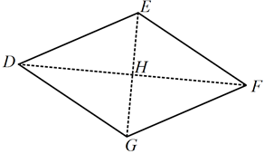
Which pair of triangles are not congruent?

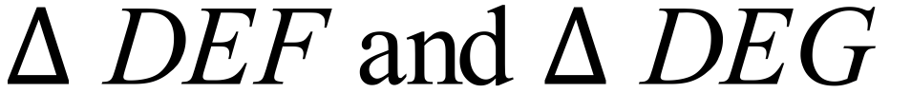
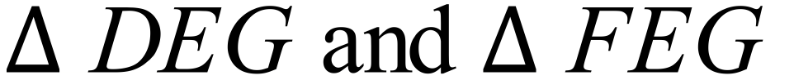
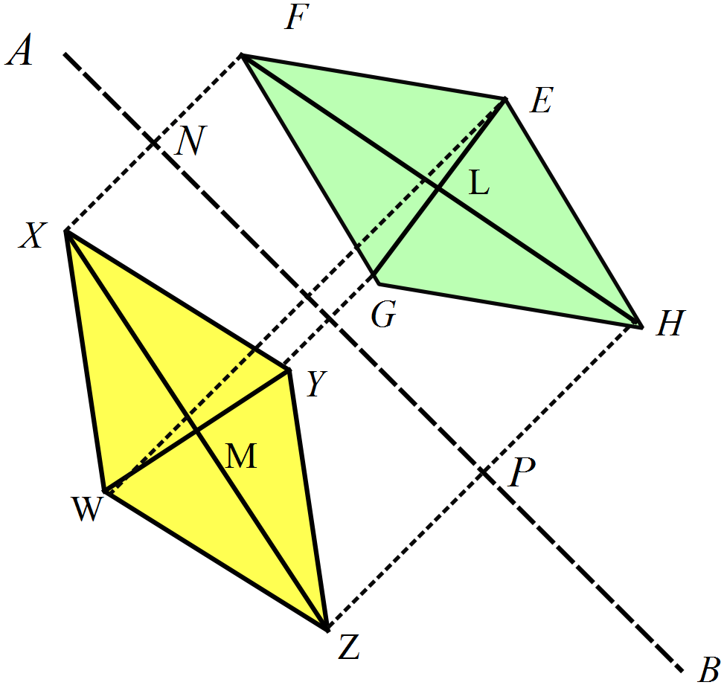The rhombus WXYZ is reflected in the line segment AB, to give the rhombus EFGH.

Which distances are equal?

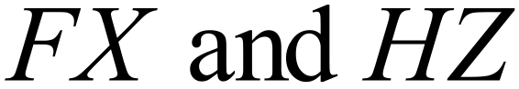

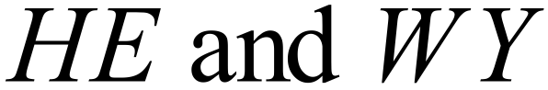


POQ is rotated through 180º about O and then the image is reflected in the y axis.
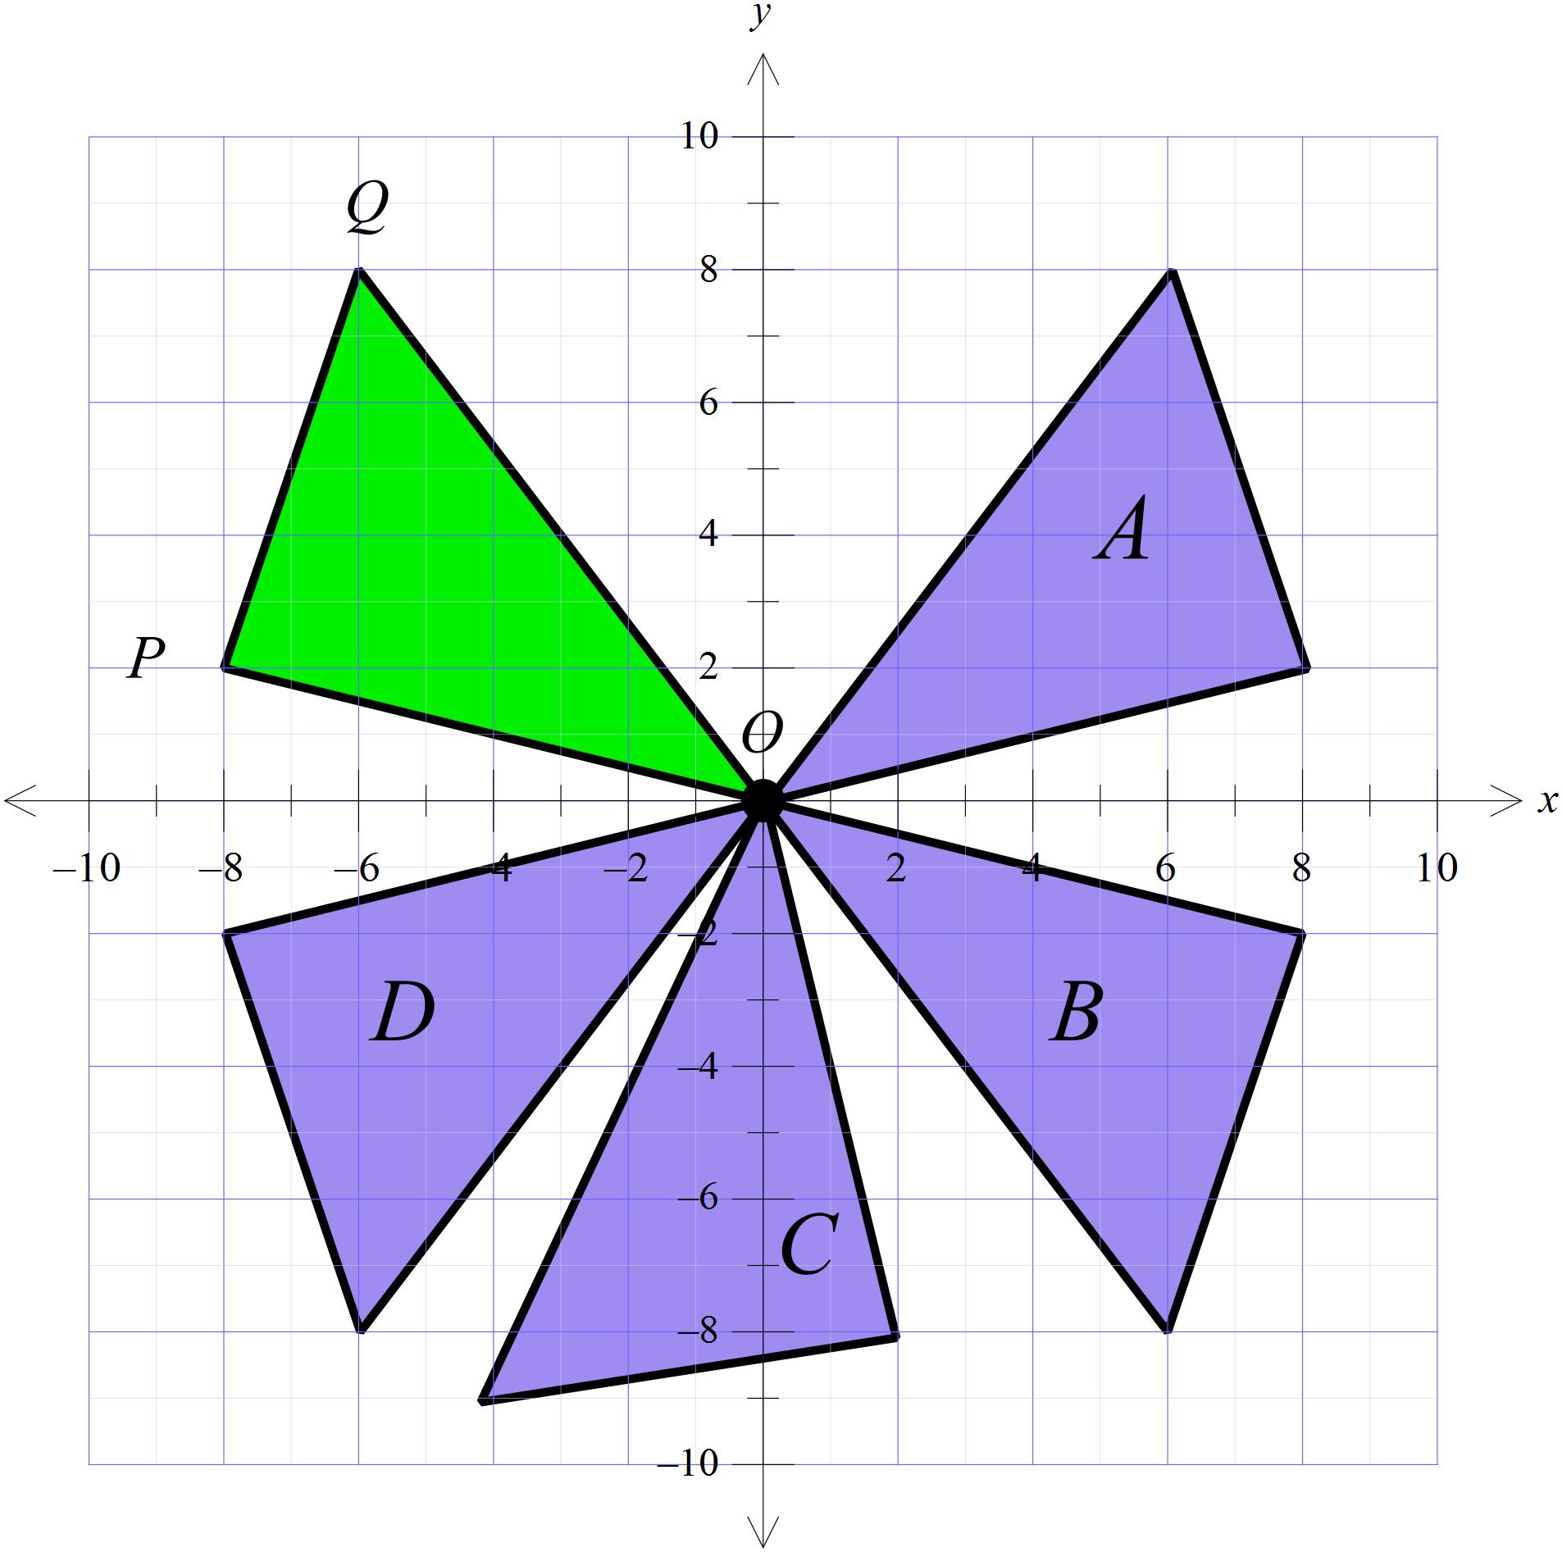
Which figure is its image?

Triangle A
Triangle B
Triangle C
Triangle D

Which of the congruence tests could be used to show that
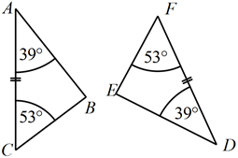

AAS RHS SAS SSS
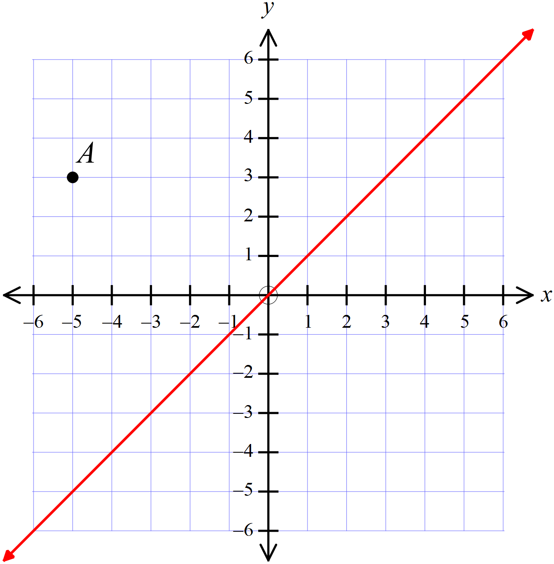The point A (–5, 3) is reflected in the line y = x. The image is then rotated through 90º in a clockwise direction about the origin.
Give the coordinates of the point which is the image after these transformations?

(–5, 3)
(–5, –3)
(–4, –4)
(3, –5)

A congruence proof has been started below.
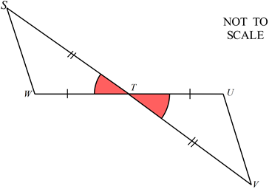
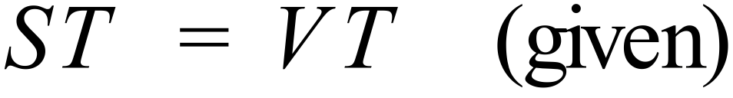
WT = UT (given)

Which of the congruence tests is used?

AAS
RHS
SAS
SSS
In the figure below AB = DE, BC = EF, 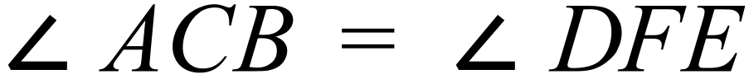 and 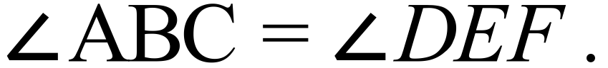
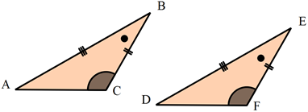

Which two congruence tests could be used to prove 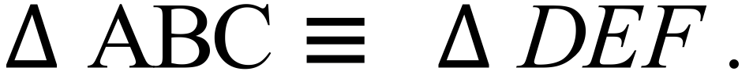
AAS and RHS
AAS and SAS
AAS and SSS
SAS and SSS
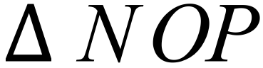 is reflected in the line y = – x and the image is then translated the distance and direction indicated by RS.
Draw the image after the two transformations.
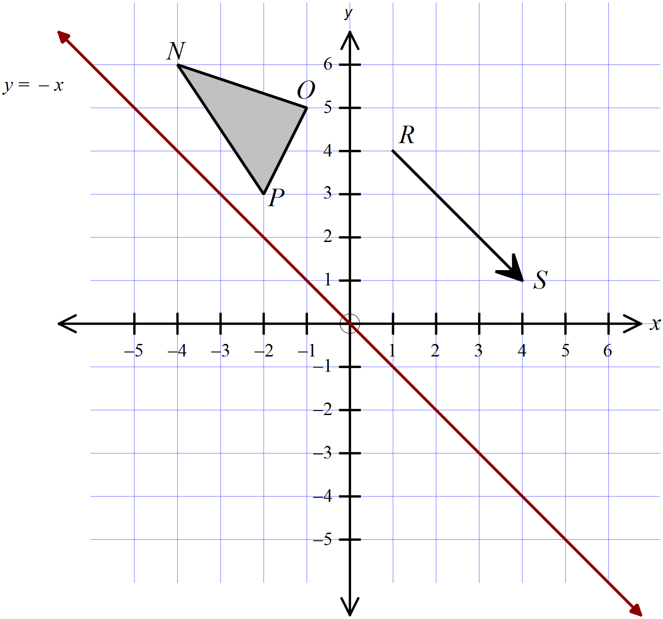

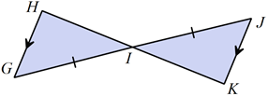
Which of the congruence tests could be used to show that 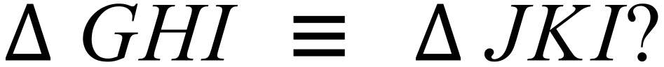.

AAS RHS SAS SSS
A roof truss for a house is a series of welded steel triangles, as shown below.
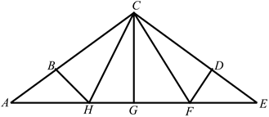
The shape has line symmetry along the line CG.

Name two pairs of congruent triangles in the figure.

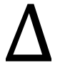 __________ and ____________ __________ and ____________
In the diagram below, AB = CD, BC = AD
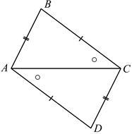

Name two congruence tests that could be used to prove that
HHlll
HHlll
and

School Name
Mathematics 2017
Year 8 | Transformations and Congruence | Calculator Allowed
Year 8 | Transformations and Congruence | Name___________________
Section 2 Longer Answer Section
Write all working and answers in the spaces provided on this test paper.

 |  | Marks
1. | (a) Draw the image when the triangle ABC is rotated through 90º in a clockwise direction about C.  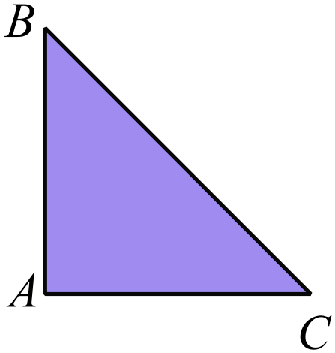  Use geometric  instruments. | 2
 | (b) Translate the figure below so that the side ST coincides with VW.  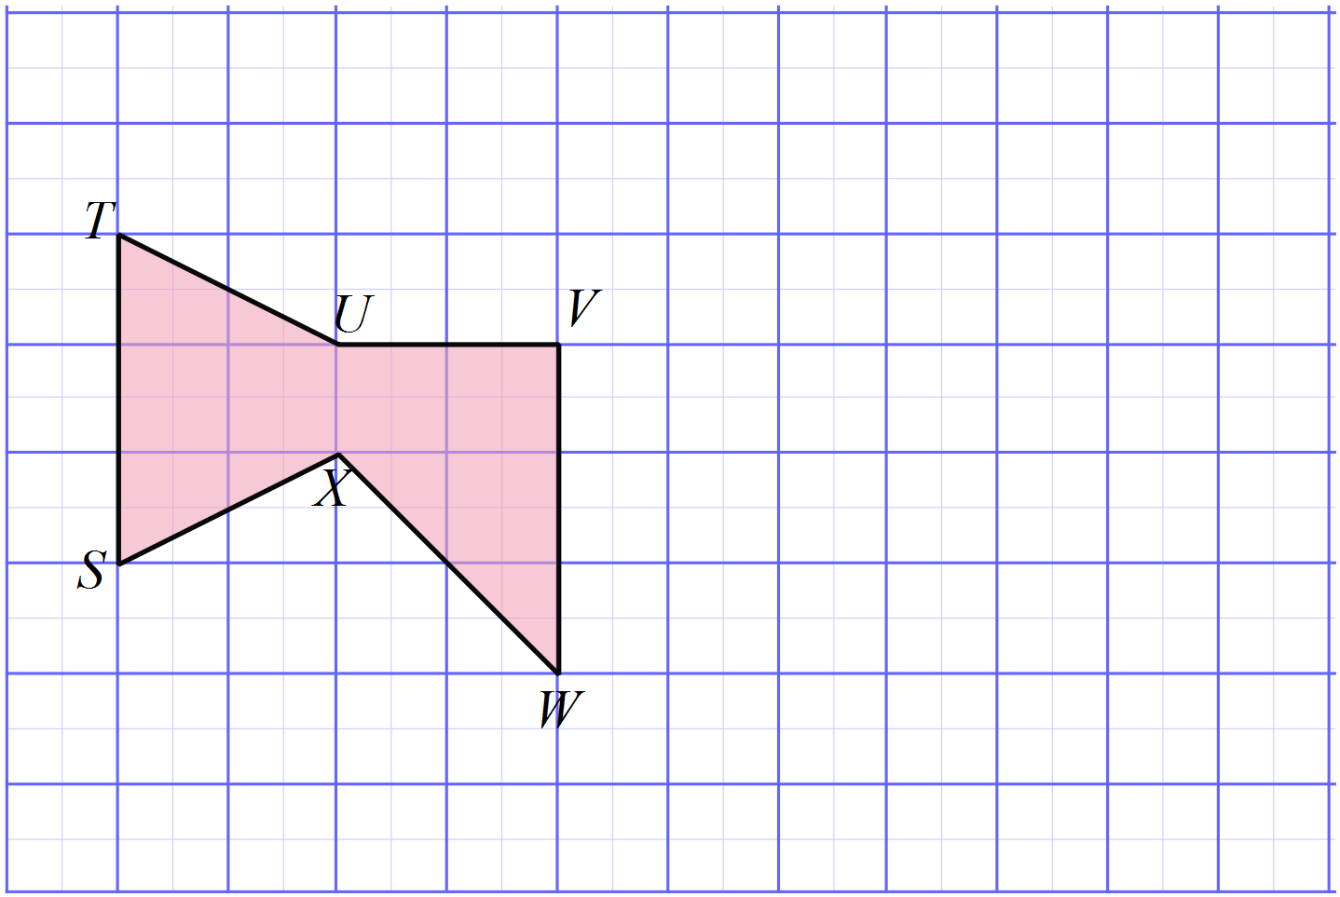 | 2
2. | (a) Draw a figure congruent to ABCD, by rotating through 180º in a clockwise direction.  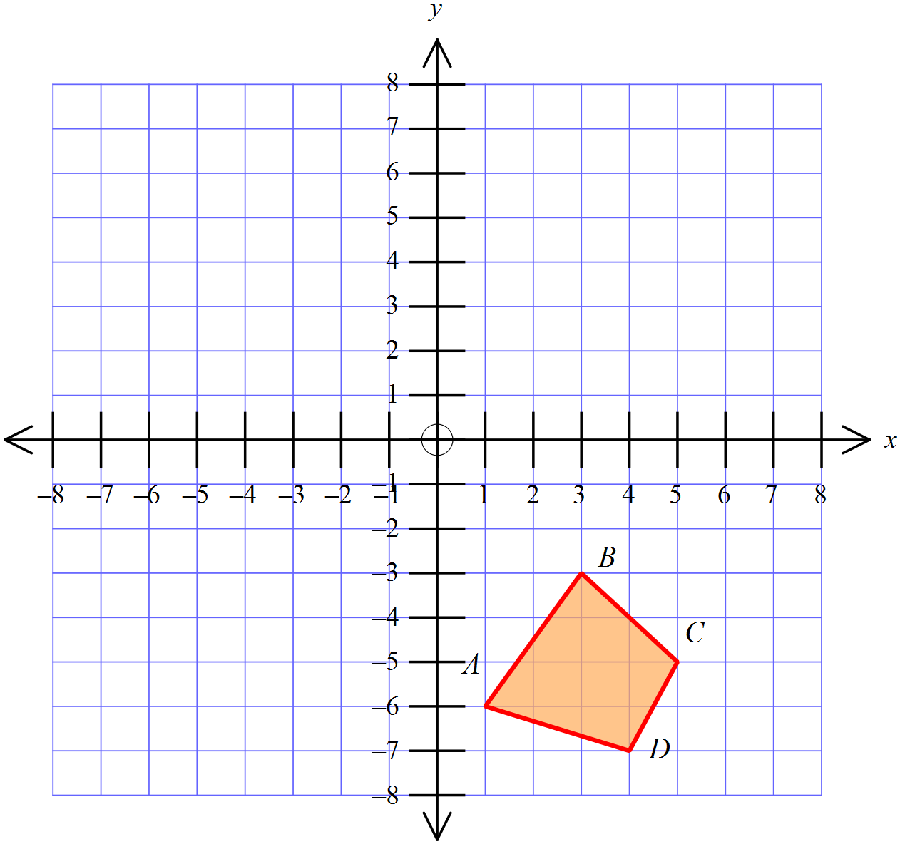 | 2
 | (b) Draw the image of the quadrilateral ABCD after a reflection in the line XY.  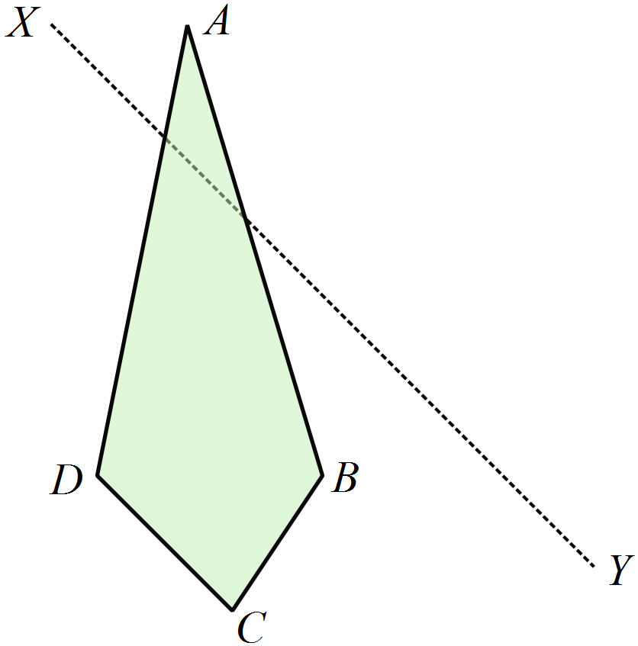 | 2
3. | (a) KL = NO, LM = PO and 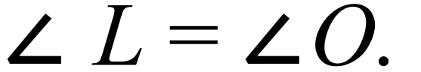  Prove that  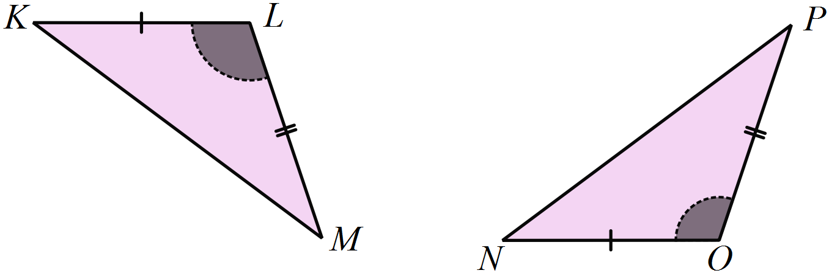  ……………………………………………………………………………………..  ……………………………………………………………………………………..  ……………………………………………………………………………………..  ……………………………………………………………………………………..  …………………………………………………………………………………….. | 2
 | (b) EFGH is a parallelogram with the diagonal EG drawn.  Using only the property that the opposite sides of a parallelogram are parallel, prove that  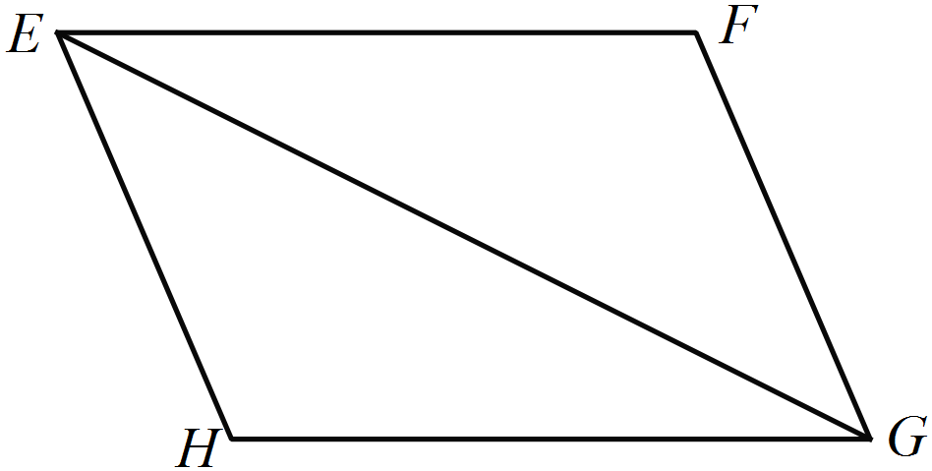  ……………………………………………………………………………………..  ……………………………………………………………………………………..  ……………………………………………………………………………………..  ……………………………………………………………………………………..  ……………………………………………………………………………………..  …………………………………………………………………………………….. | 3

School Name
Mathematics Test 2017
Year 8 | Transformations and Congruence | Non Calculator Test
ANSWERS

Question | Working and Answer
There are 4 axes as shown
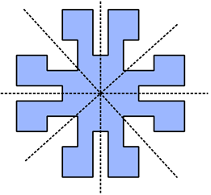

Order 4 as each point can be rotated to a new position and it still looks the same.
2nd Answer

Since B is the centre of the rotation it’s image is in the same position.

3rd Answer

 | 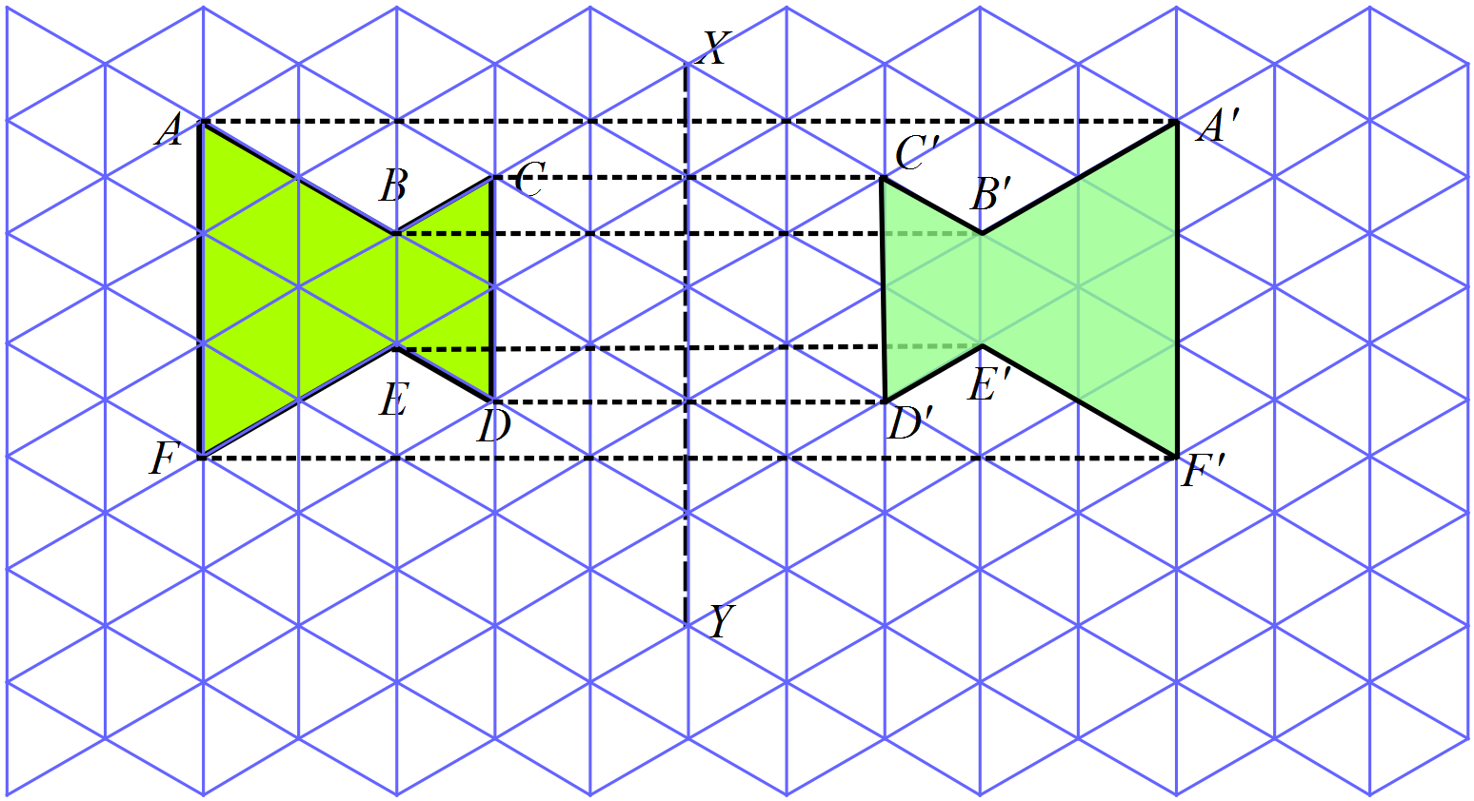
 | 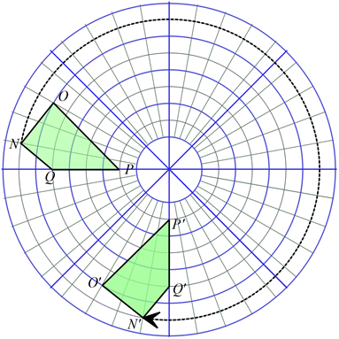
Order 3 as it can be rotated through 120º twice and appears the same each time.
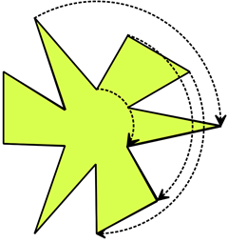
3rd Answer

 | 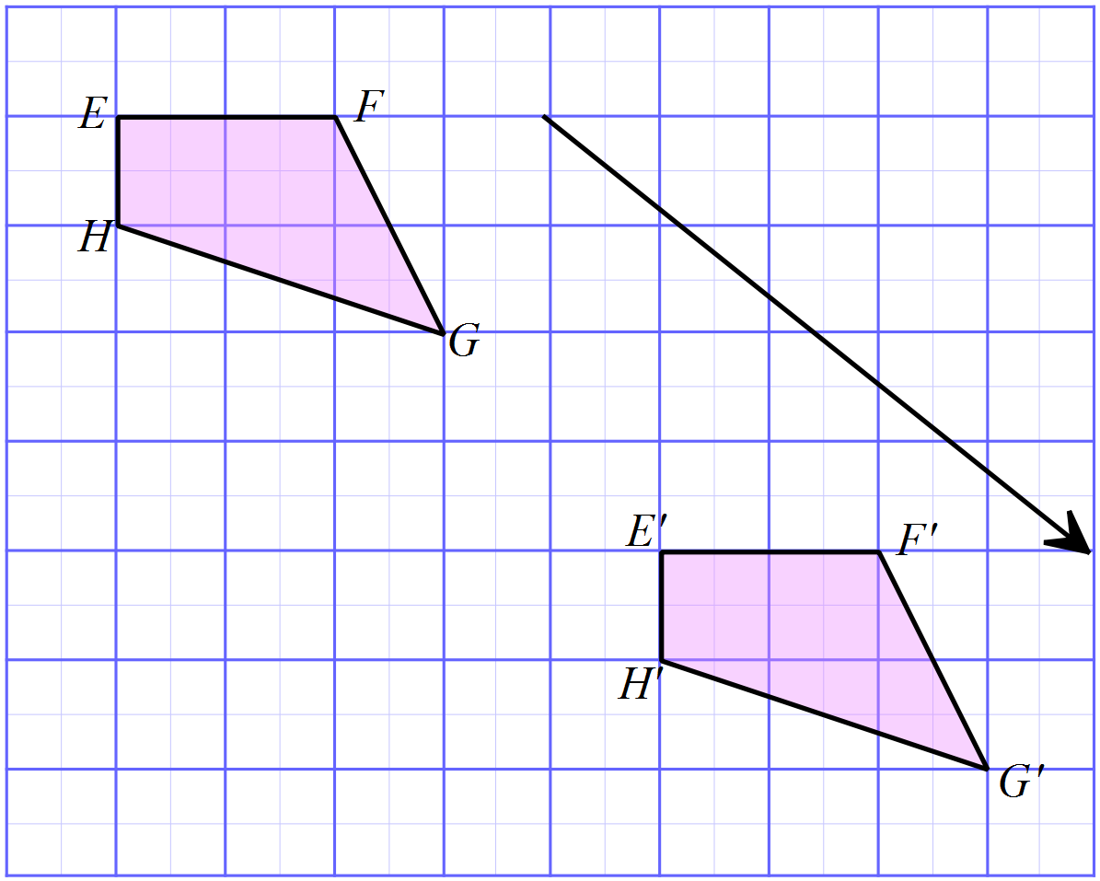
O and Q have their image in the same position and P is flipped over, to give the third diagram.
3rd Answer

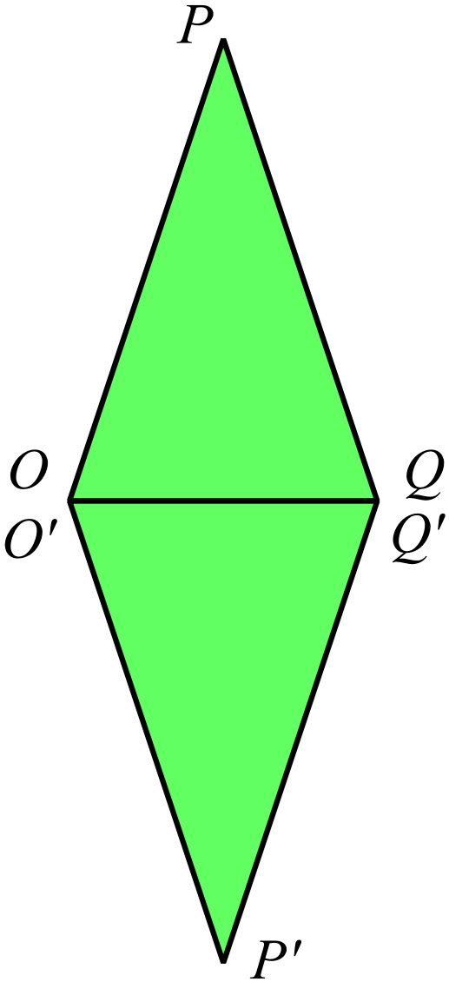

It is a rotation through 180º
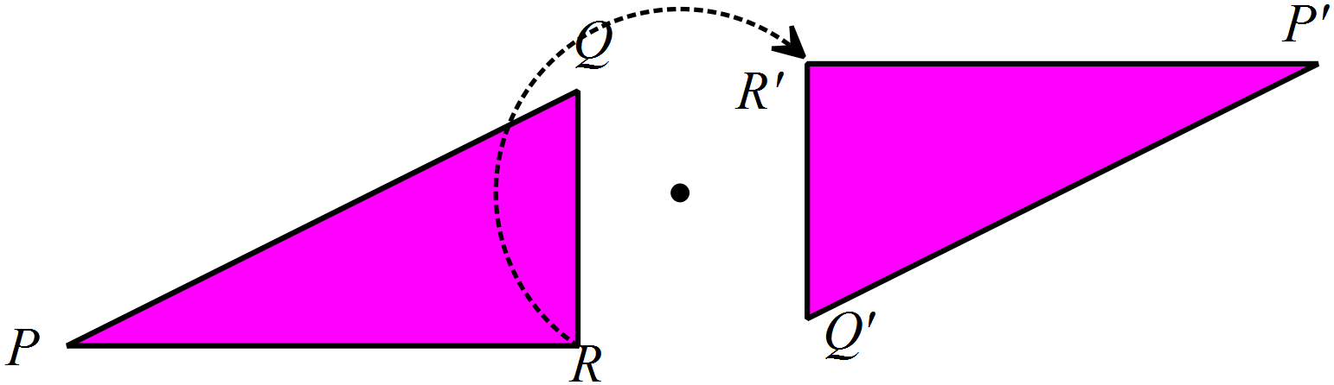1st Answer

The rectangle has two axes of symmetry.
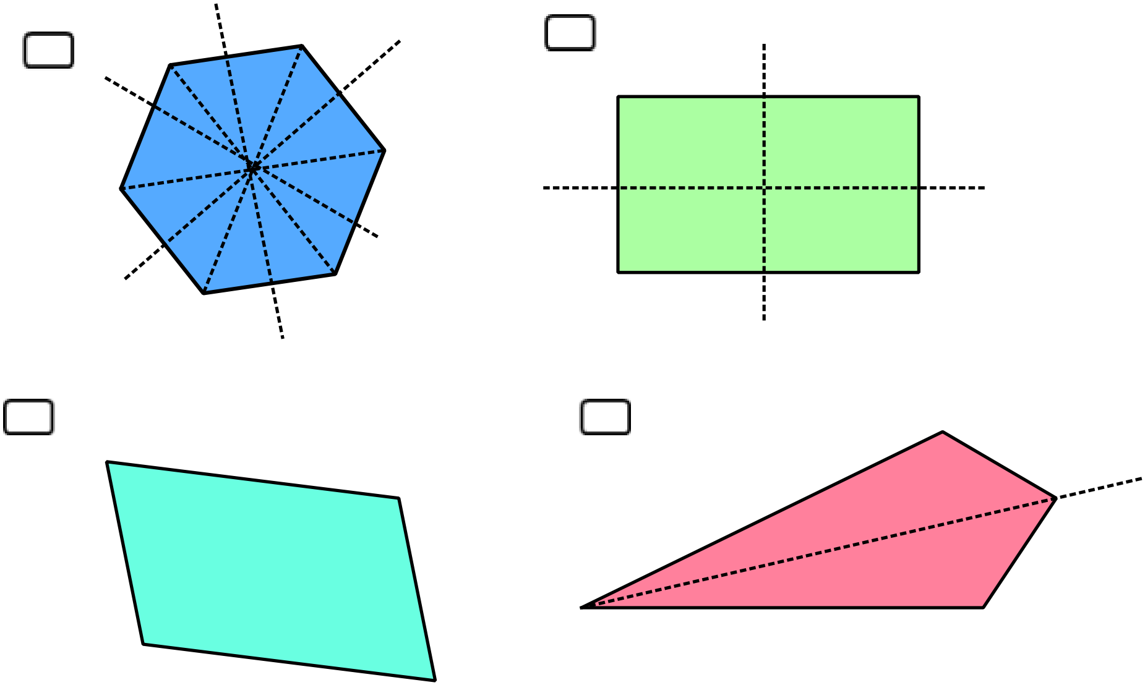2nd Answer

 | 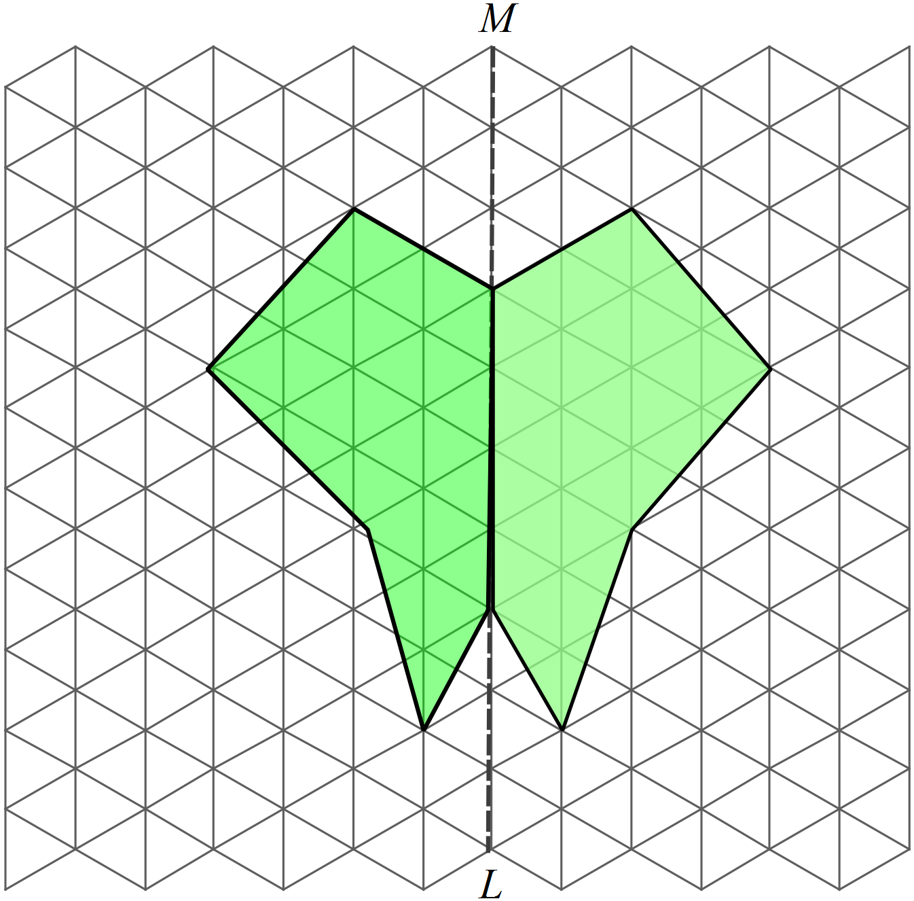
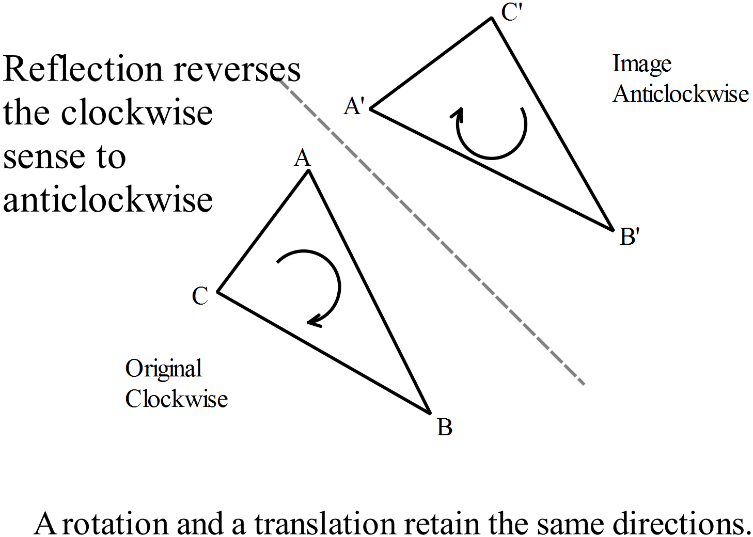

4th Answer
K goes to B as shown.
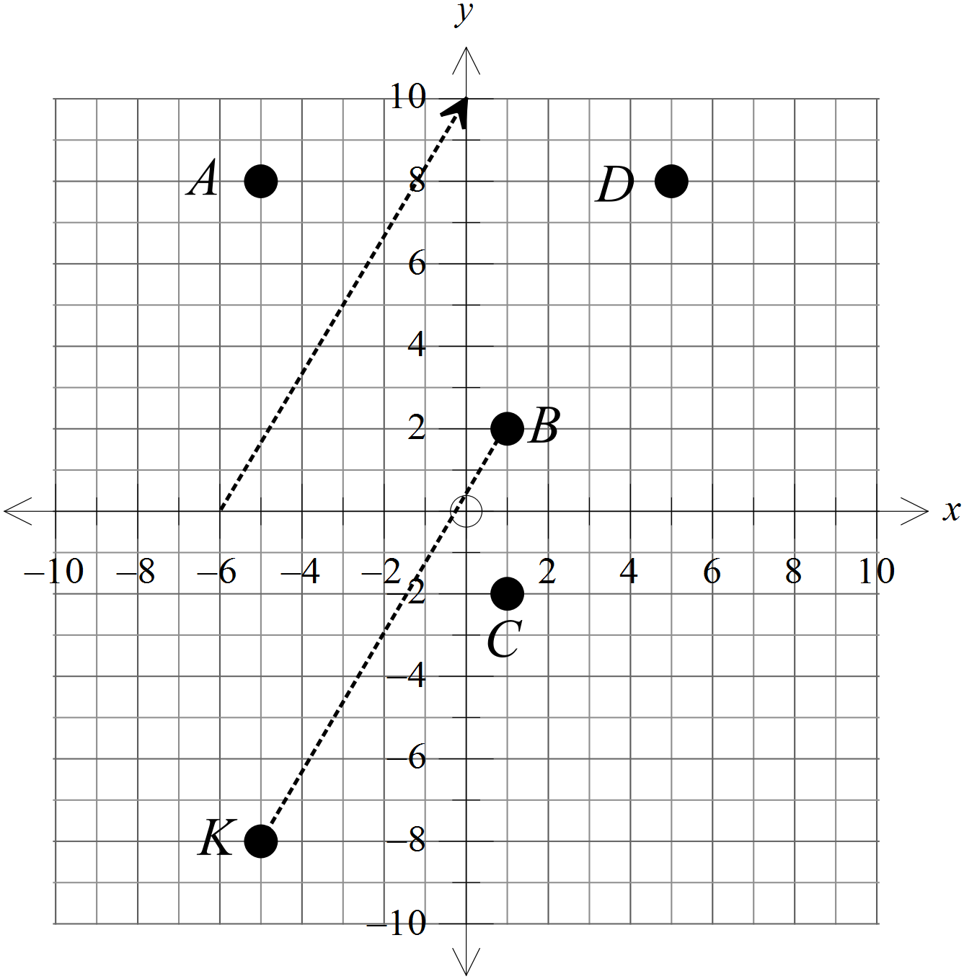

2nd Answer
 | 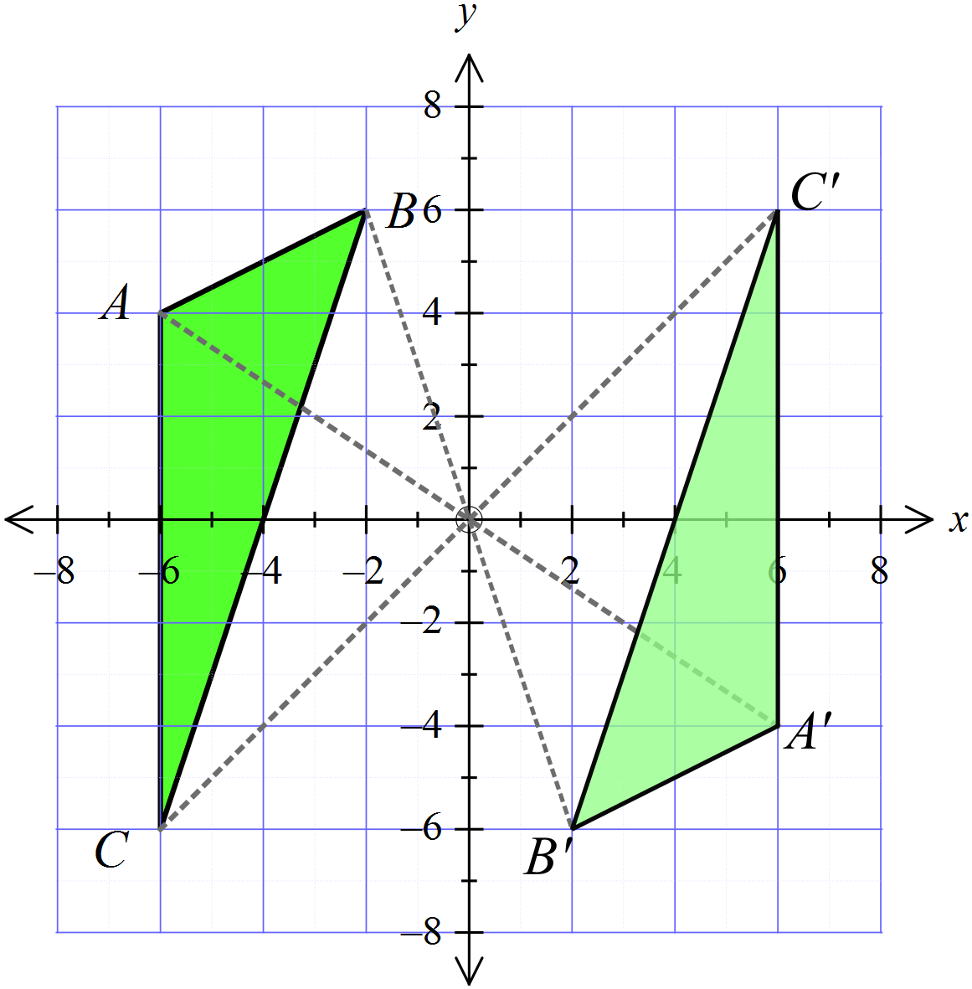
 | 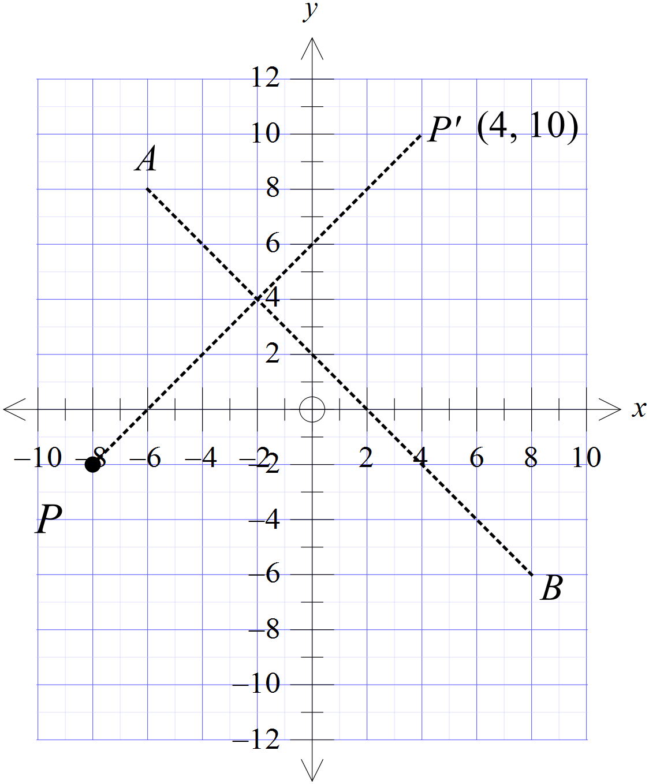(4, 10)
 | 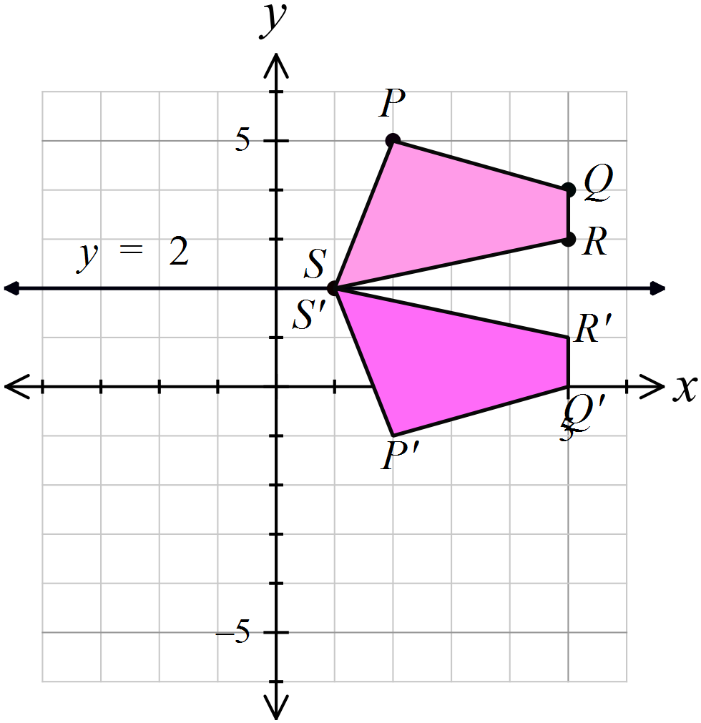
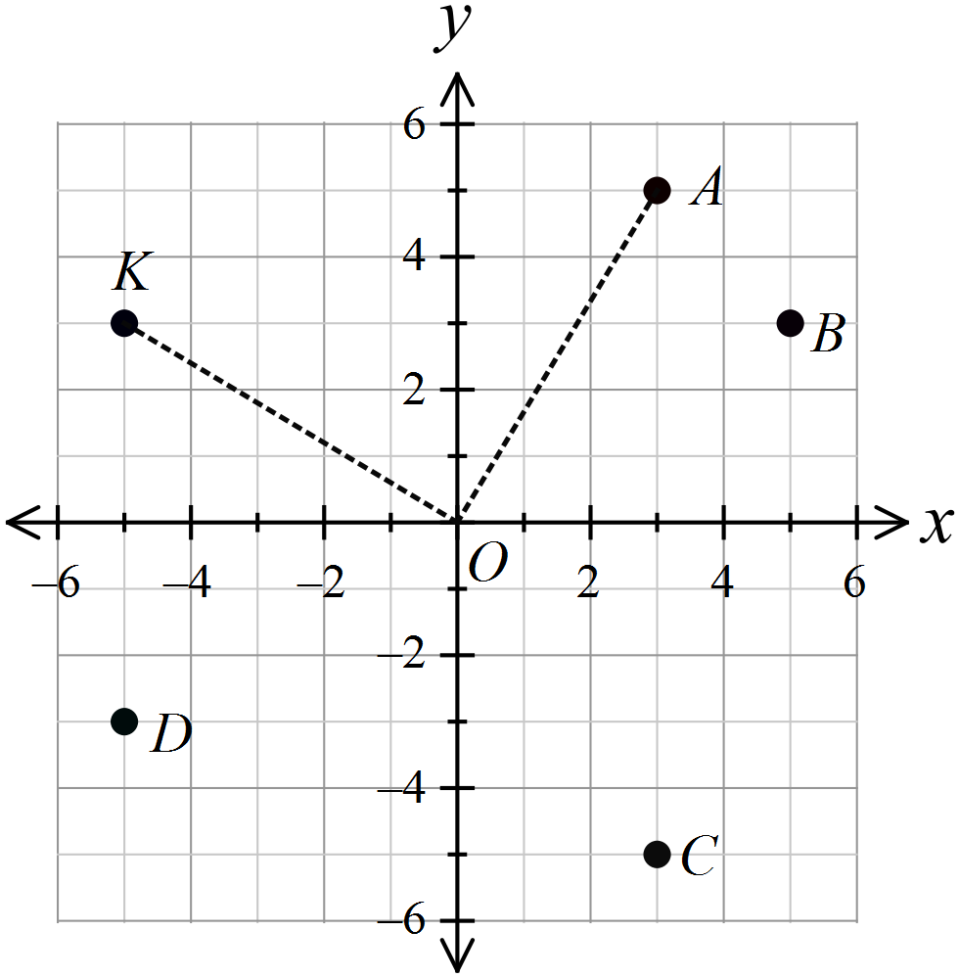

1st Answer

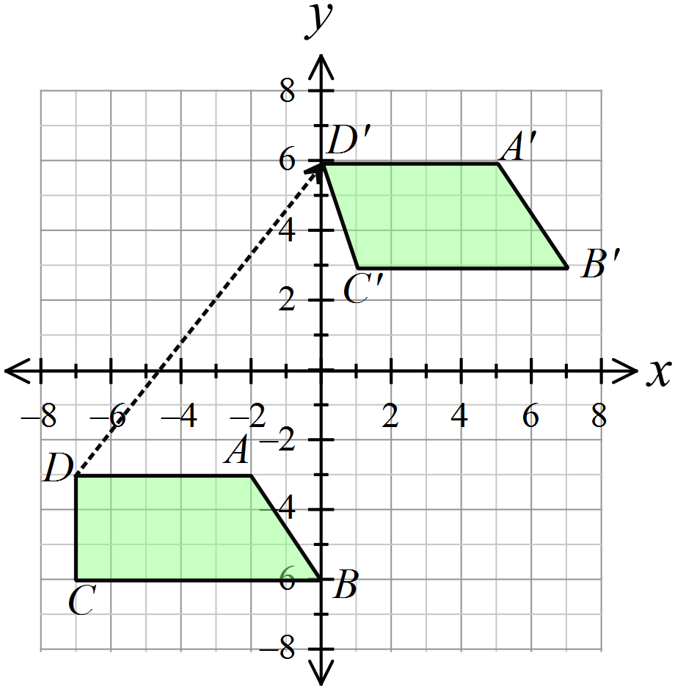

A translation in the direction of the arrow shown
4th Answer
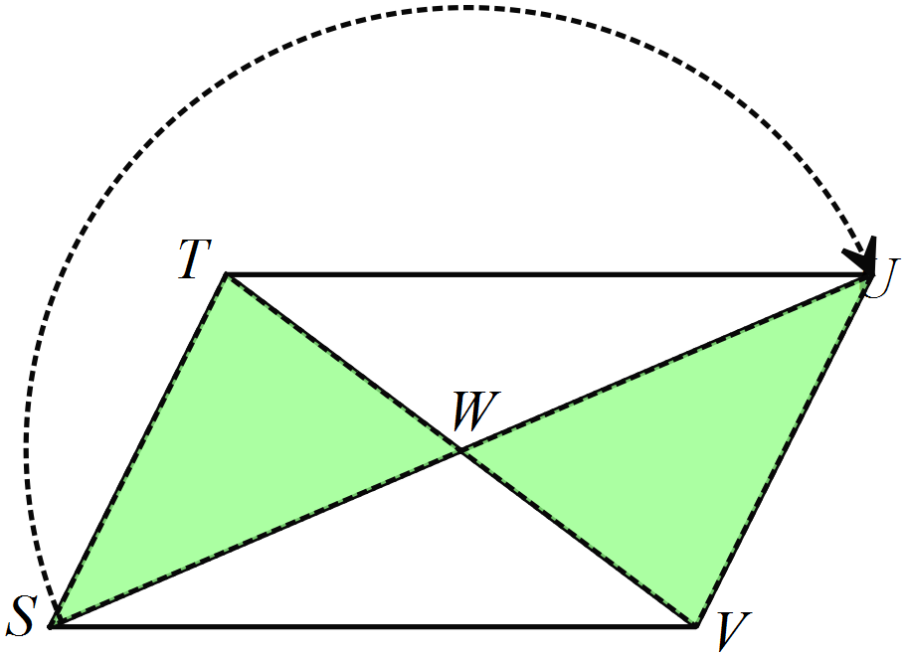

A rotation of 180º.
3rd Answer
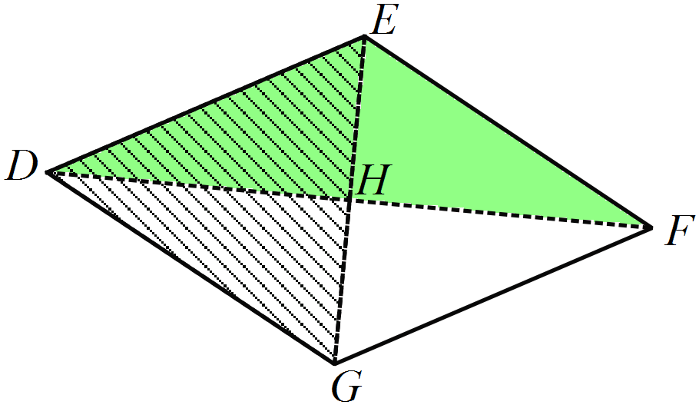

2nd Answer
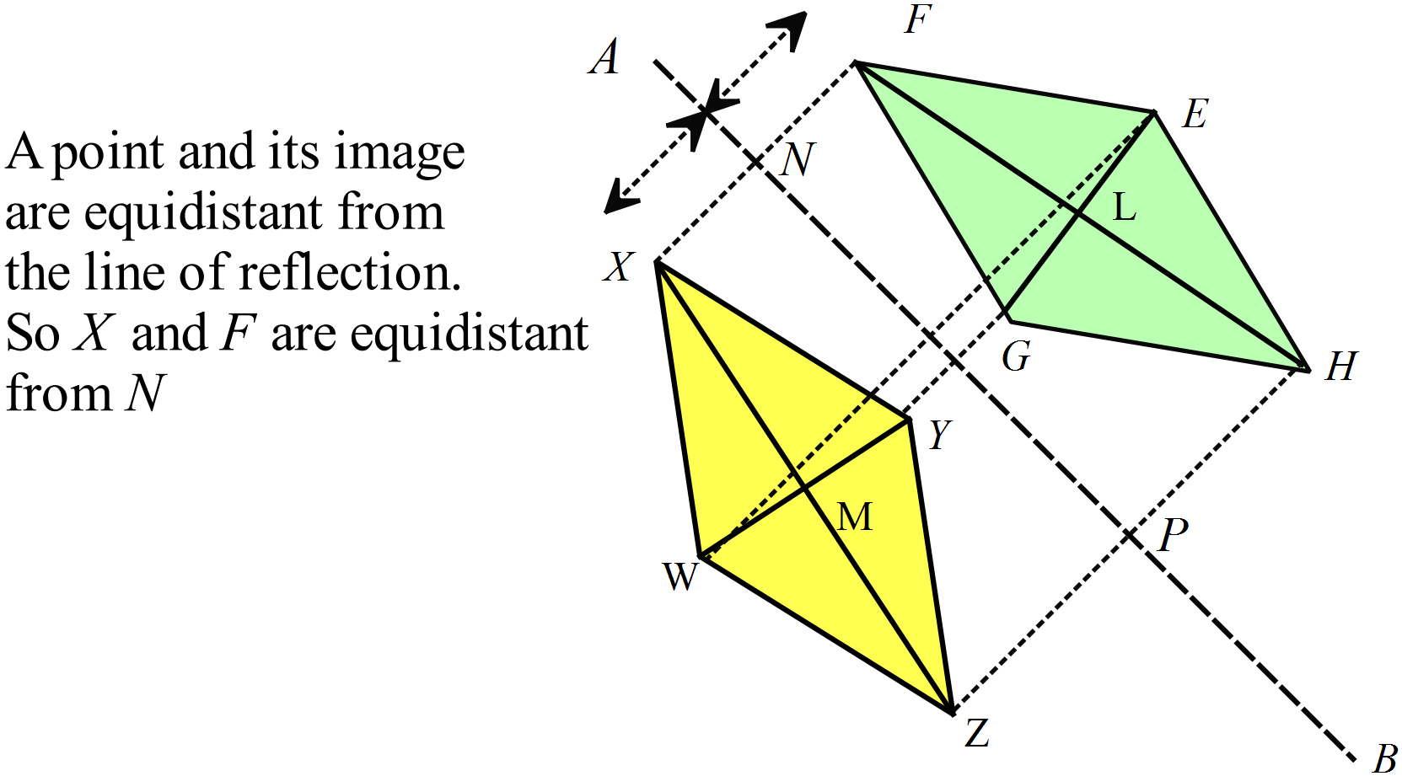

2nd Answer

Rotation through 180º gives triangle B which is then reflected in the y axis to give triangle D.
4th Answer

There are two pairs of corresponding angles equal with the included side also equal.
ASS

1st Answer
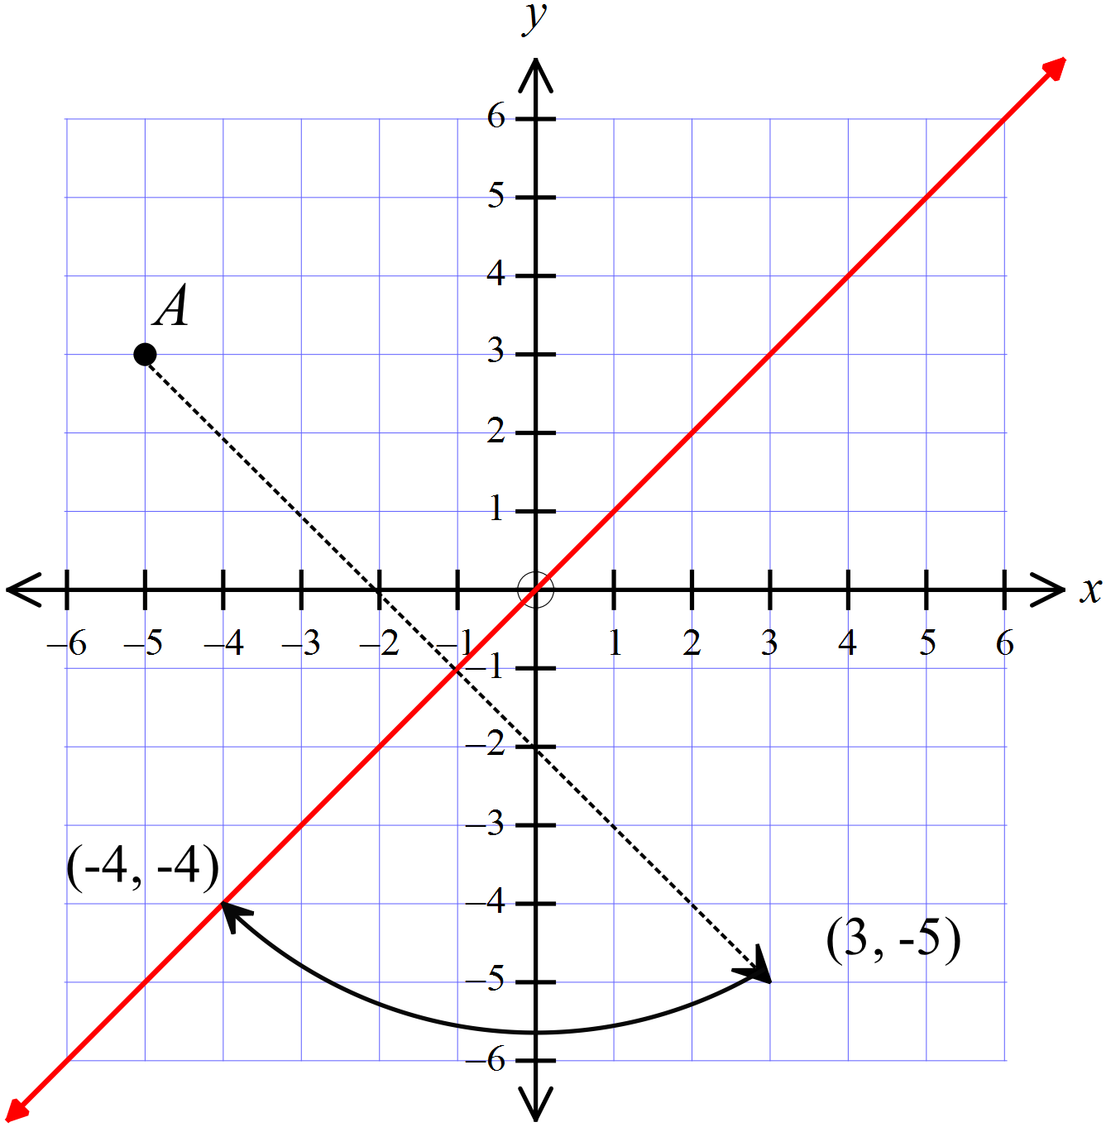

3rd Answer

Two sides and an included angle (SAS).

3rd Answer
AAS and SAS

2nd Answer
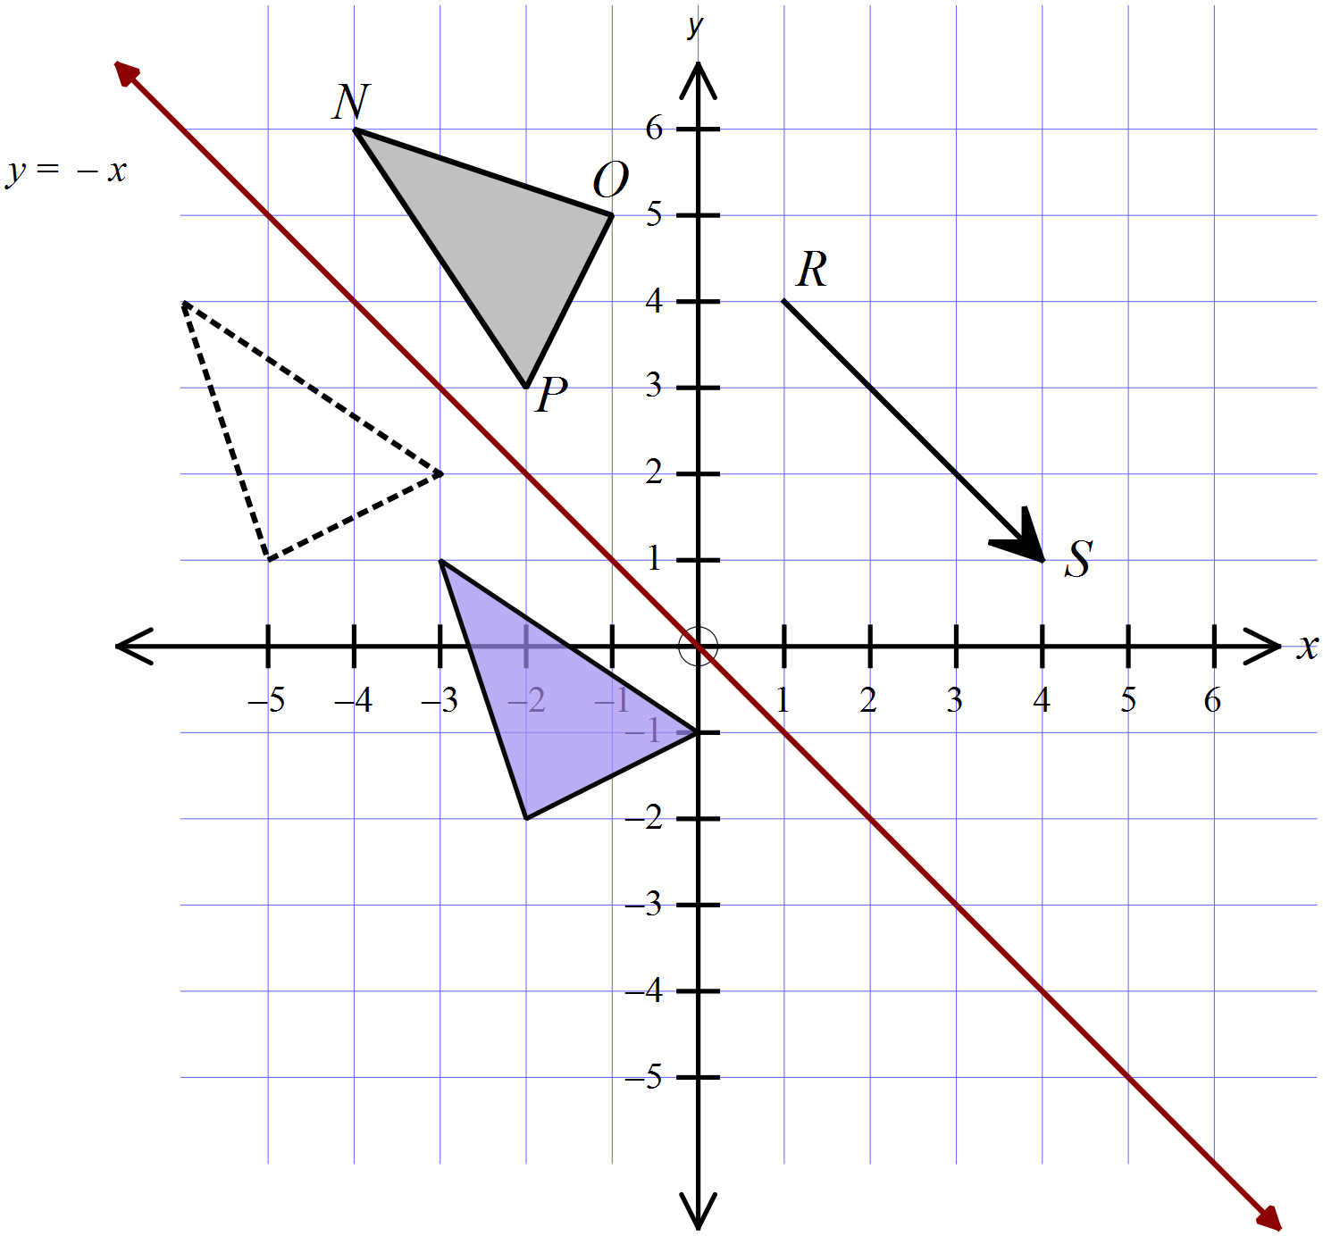

Diagram with two triangle drawn.
There are a pair of equal vertically opposite angles and a pair of equal alternate angles, which together with the given sides being equal allow proof using AAS.

1st Answer

Any two pairs.
Some examples are :
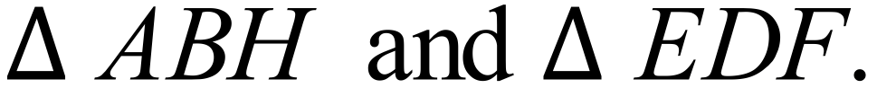
AC is common, so this allows SSS, since two sides are already given.
AC being common, along with BC = AD and the angle given allows SAS.

School Name
Mathematics Test 2017
Year 8 | Transformations and Congruence | Longer Answer  Section
ANSWERS
Question | Answer | Marks
1. | (a)  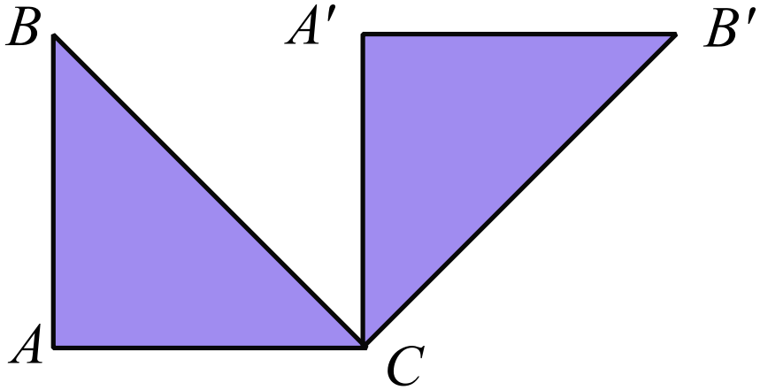 | 2 marks for an accurate drawing.  1 mark if inaccurate or a minor error.
 | 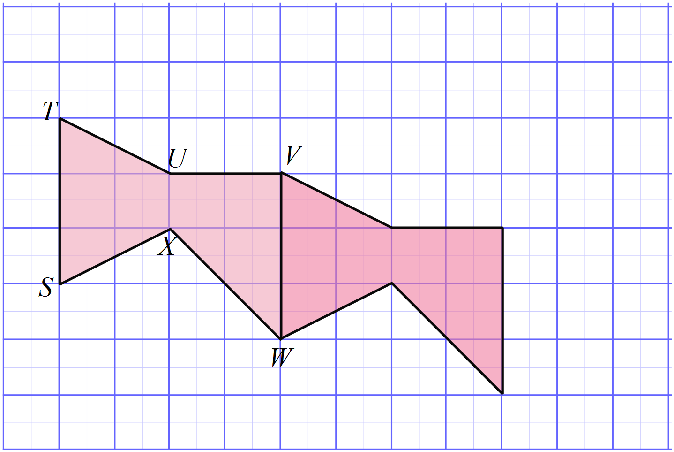 | 2 marks for an accurate drawing.  1 mark if inaccurate or a minor error.
2. | (a)  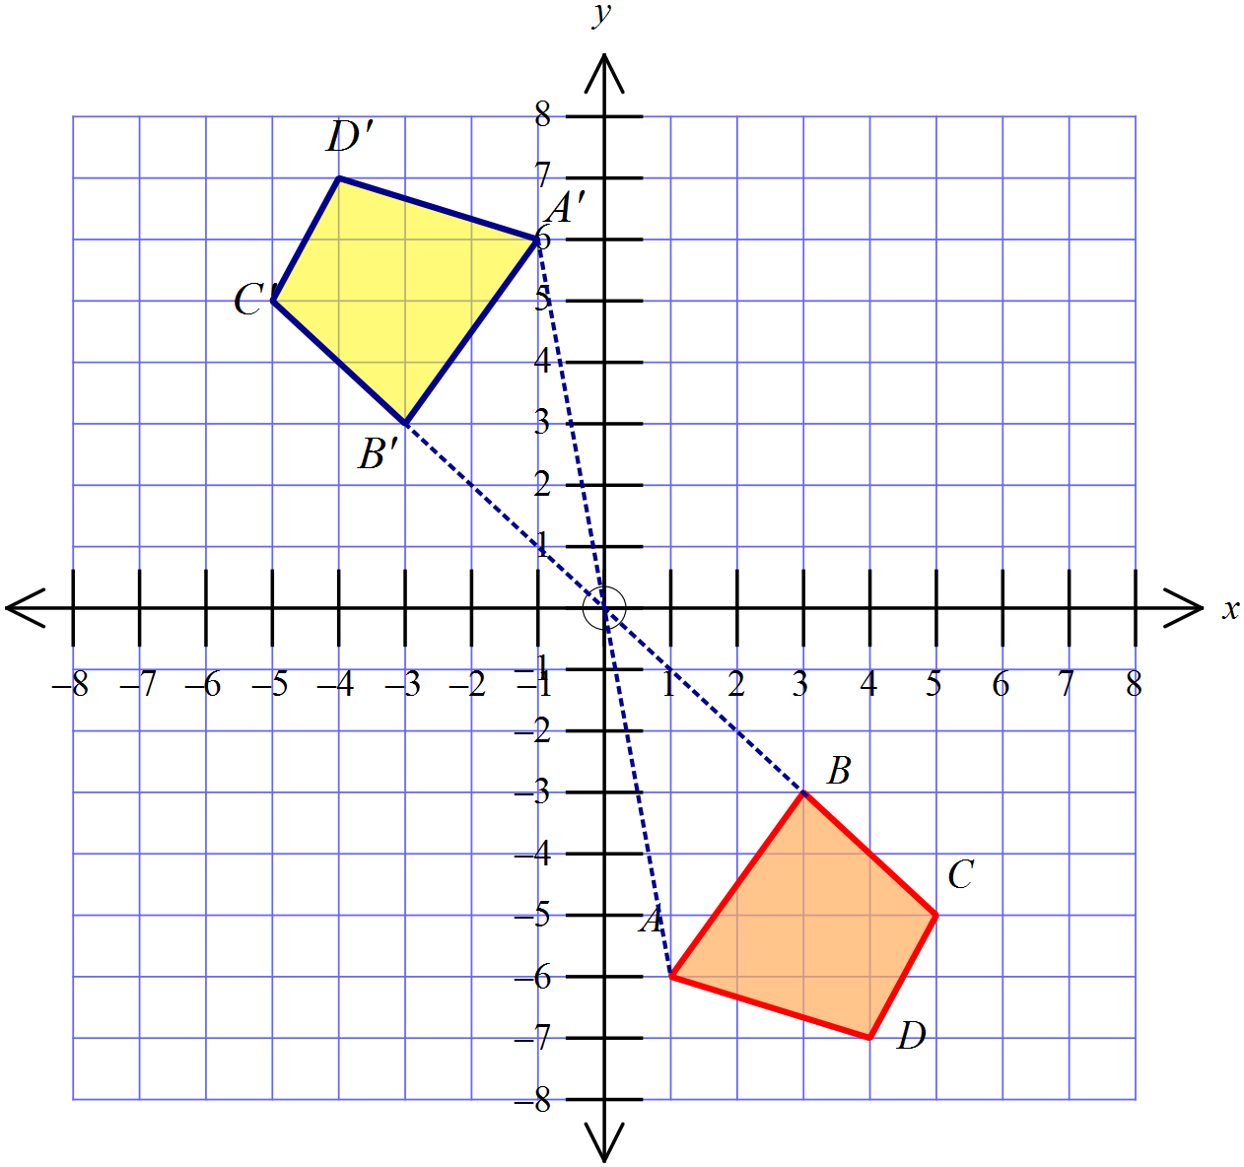 | 2 marks for an accurate and correct drawing of the image.  1 mark for an inaccurate drawing or one with a minor error
 | 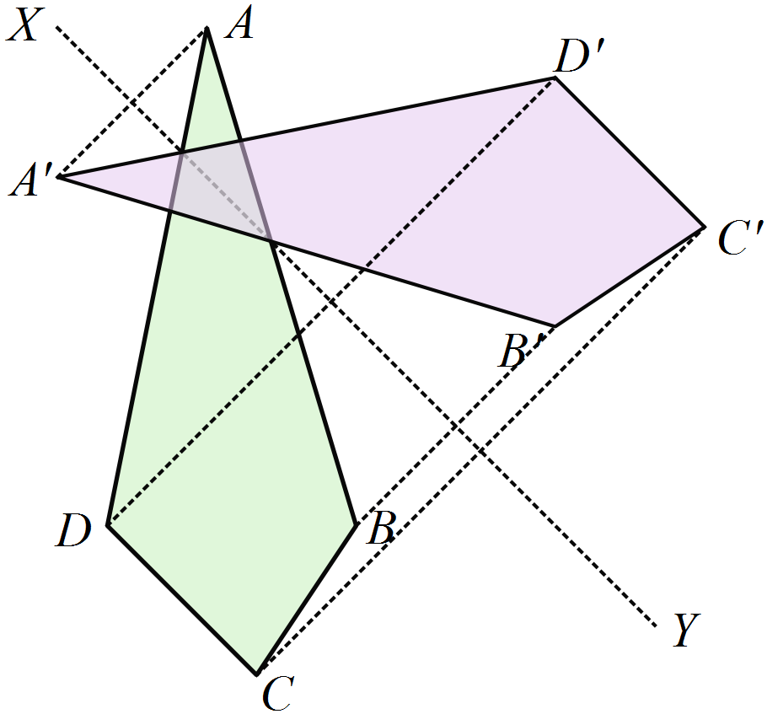(b) | 2 marks for an accurate and correct drawing of the image.  1 mark for an inaccurate drawing or one with a minor error
3. | (a) 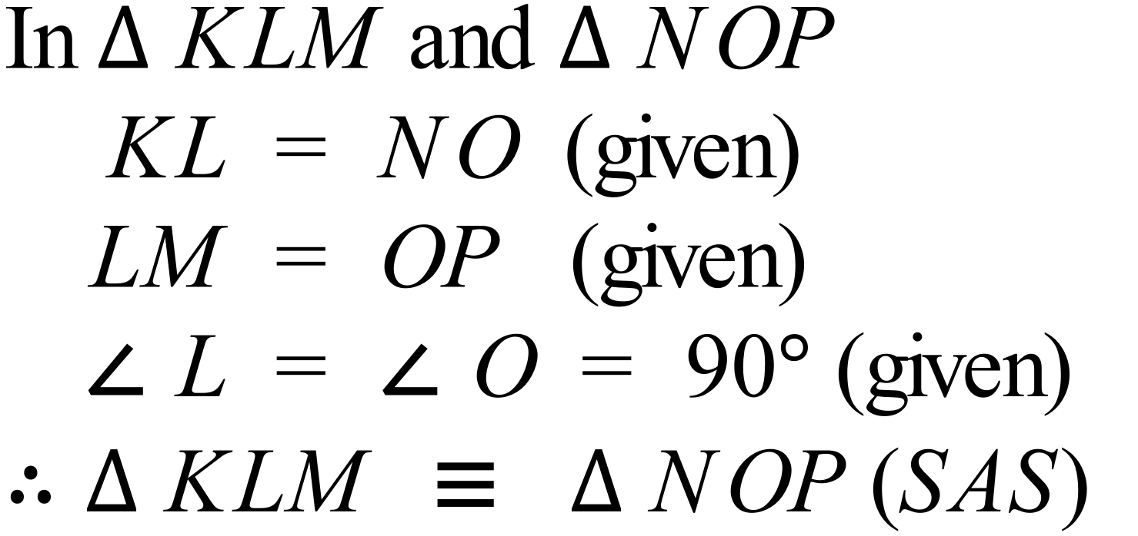 | 2 marks for stating the three equal features and stating congruence with SAS.  1 mark for a partial proof or incorrect conclusion
 | (b)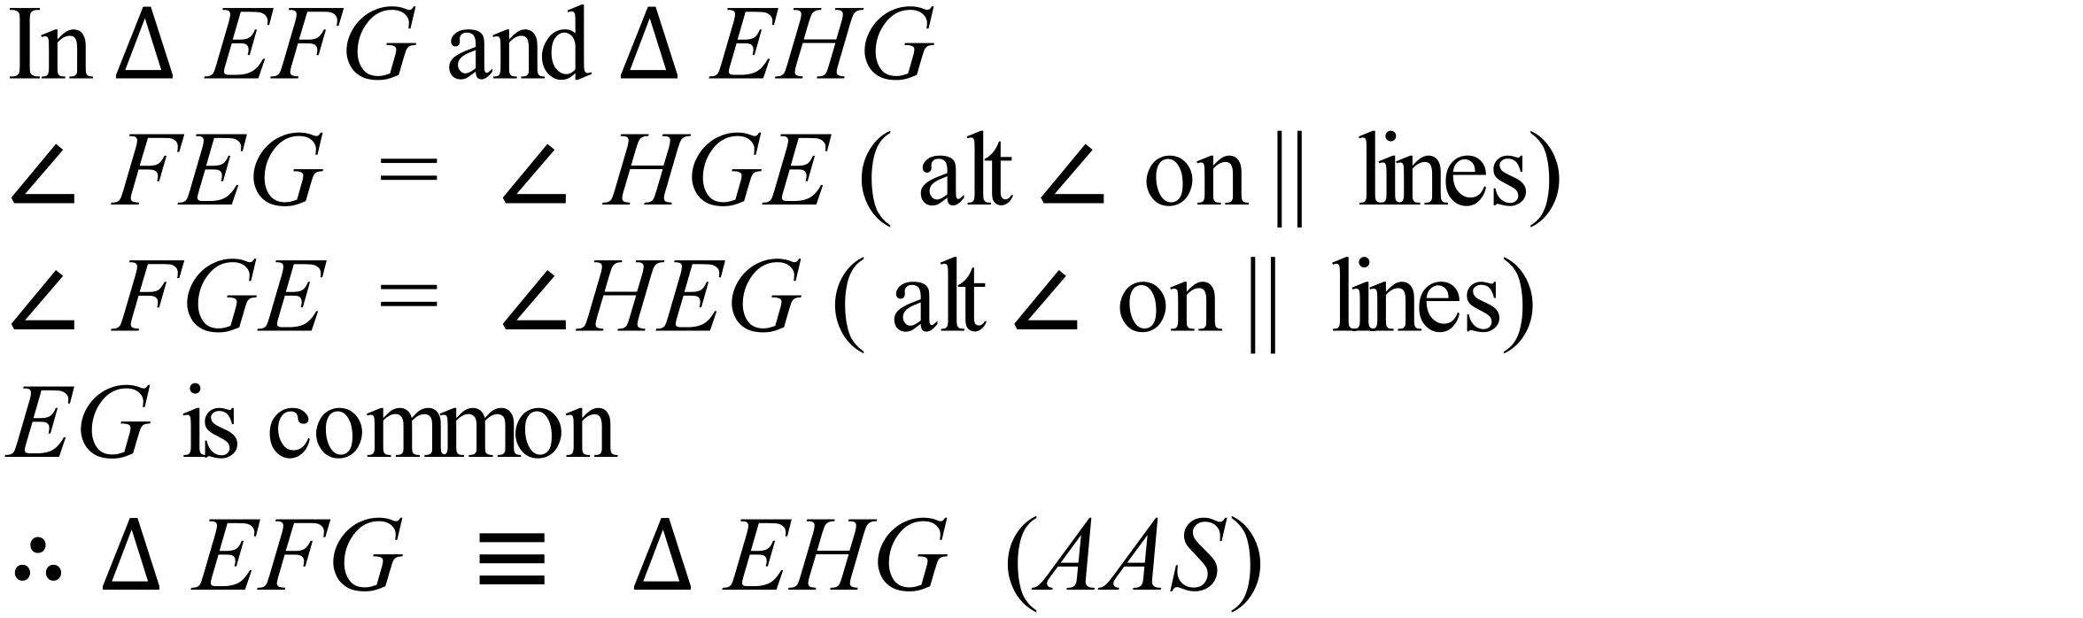 | 3 marks for stating the three equal features and including the reasons for the two angles being equal and stating congruence with AAS.  2 marks for a proof without one of the reasons or with another minor error or an incorrect conclusion  1 mark for a proof without reasons or incorrect reasons, or which is only a partial attempt at the proof

